- Architect network infrastructure in Azure

Connect your on-premises network to Azure with VPN Gateway

VPN Gateway in Azure provides secure connectivity between your on-premises networks and clients.
Suppose you're the network architect at a regional healthcare provider. The organization has migrated much of its infrastructure to Azure. You'd like to connect your datacenter and larger regional facilities to Azure. You need secure connectivity so that patient health information is protected while it's crossing the network. You don't currently have the bandwidth requirements for a dedicated circuit, and you're looking for a way to integrate these networks in a cost-effective way.

Connect on-premises networks to Azure by using site-to-site VPN gateways

A virtual private network (VPN) is a type of private interconnected network. VPNs use an encrypted tunnel within another network. They're typically deployed to connect two or more trusted private networks to one another over an untrusted network (typically the public Internet). Traffic is encrypted while traveling over the untrusted network to prevent eavesdropping or other attacks.

This medical data is stored on a system in Azure. A VPN that connects the facility to Azure allows the surgical team to securely access this information.

Azure VPN gateways
A VPN gateway is a type of Virtual Network Gateway. VPN gateways are deployed in Azure virtual networks and enable the following connectivity:
- Connect on-premises datacenters to Azure virtual networks through a site-to-site connection.
- Connect individual devices to Azure virtual networks through a point-to-site connection.
- Connect Azure virtual networks to other Azure virtual networks through a network-to-network connection.
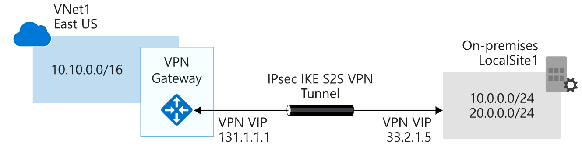
When you deploy a VPN gateway, you specify the VPN type: either policy-based or route-based. The main difference of these two types of VPNs is how traffic to be encrypted is specified

Policy-based VPNs
Policy-based VPN gateways specify statically the IP address of packets that should be encrypted through each tunnel. This type of device evaluates every data packet against those sets of IP addresses to choose the tunnel where that packet is going to be sent through. Key features of policy-based VPN gateways in Azure include:
- Support for IKEv1 only.
- Use of static routing, where combinations of address prefixes from both networks control how traffic is encrypted and decrypted through the VPN tunnel. The source and destination of the tunneled networks are declared in the policy and don't need to be declared in routing tables.
- Policy-based VPNs must be used in specific scenarios that require them, such as for compatibility with legacy on-premises VPN devices.

Route-based VPNs
If defining which IP addresses are behind each tunnel is too cumbersome, route-based gateways can be used. With route-based gateways, IPSec tunnels are modeled as a network interface or VTI (virtual tunnel interface). IP routing (static routes or dynamic routing protocols) decide across which one of these tunnel interfaces to send each packet. Route-based VPNs are the preferred connection method for on-premises devices, since they are more resilient to topology changes such as the creation of new subnets, for example. Use a route-based VPN gateway if you need any of the following types of connectivity:
- Connections between virtual networks
- Point-to-site connections
- Multisite connections
- Coexistence with an Azure ExpressRoute gateway
Key features of route-based VPNs gateways in Azure include:
- Supports IKEv2.
- Uses any-to-any (wildcard) traffic selectors.
- Can use dynamic routing protocols, where routing/forwarding tables direct traffic to different IPSec tunnels.

Both types of VPN gateways (route-based and policy-based) in Azure use pre-shared key as the only method of authentication. Both types also rely on Internet Key Exchange (IKE) in either version 1 or version 2 and Internet Protocol Security (IPSec). IKE is used to set up a security association (an agreement of the encryption) between two endpoints. This association is then passed to the IPSec suite, which encrypts and decrypts data packets encapsulated in the VPN tunnel.

VPN gateway sizes
The capabilities of your VPN gateway are determined by the SKU or size that you deploy. This table shows the main capabilities of each available SKU:
VPN GATEWAY SIZES
SKU | Site-to-site/VNet-to-VNet tunnels | Aggregate throughput benchmark | Border Gateway Protocol (BGP) support
Basic* | Maximum: 10 | 100 Mbps | Not supported
VpnGw1/Az | Maximum: 30 | 650 Mbps | Supported
VpnGw2/Az | Maximum: 30 | 1 Gbps | Supported
VpnGw3/Az | Maximum: 30 | 1.25 Gbps | Supported
Basic VPN Gateway should only be used for Dev/Test workloads. In addition, it is unsupported to migrate from Basic to any VpnGw#/Az sku at a later time without having to remove the gateway and redeploy.

Required Azure resources
You'll need these Azure resources before you can deploy an operational VPN gateway:
Virtual network. Deploy an Azure virtual network with enough address space for the additional subnet that you'll need for the VPN gateway
GatewaySubnet. Deploy a subnet called GatewaySubnet for the VPN gateway. Use at least a /27 address mask to make sure you have enough IP addresses in the subnet for future growth.
Public IP address. Create a Basic-SKU dynamic public IP address if using a non-zone-aware gateway.
Local network gateway. Create a local network gateway to define the on-premises network's configuration: where the VPN gateway will connect and what it will connect to.
Virtual network gateway. Create the virtual network gateway to route traffic between the virtual network and the on-premises datacenter or other virtual networks.
Connection. Create a Connection resource to create a logical connection between the VPN gateway and the local network gateway.
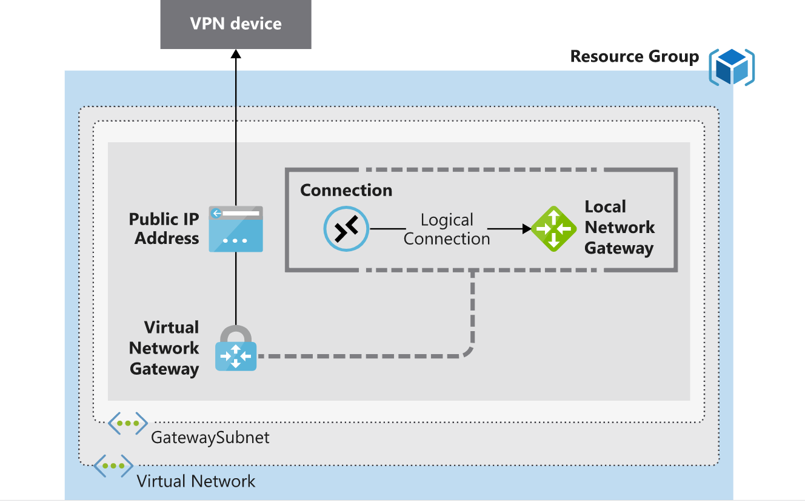

Required on-premises resources
To connect your datacenter to a VPN gateway, you'll need these on-premises resources:
- A VPN device that supports policy-based or route-based VPN gateways
- A public-facing (internet-routable) IPv4 address

Active/standby
By default, VPN gateways are deployed as two instances in an active/standby configuration, even if you only see one VPN gateway resource in Azure. When planned maintenance or unplanned disruption affects the active instance, the standby instance automatically assumes responsibility for connections without any user intervention.
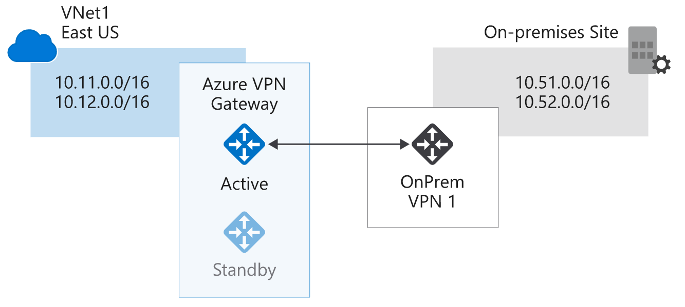

Active/active
With the introduction of support for the BGP routing protocol, you can also deploy VPN gateways in an active/active configuration. In this configuration, you assign a unique public IP address to each instance. You then create separate tunnels from the on-premises device to each IP address. You can extend the high availability by deploying an additional VPN device on-premises.
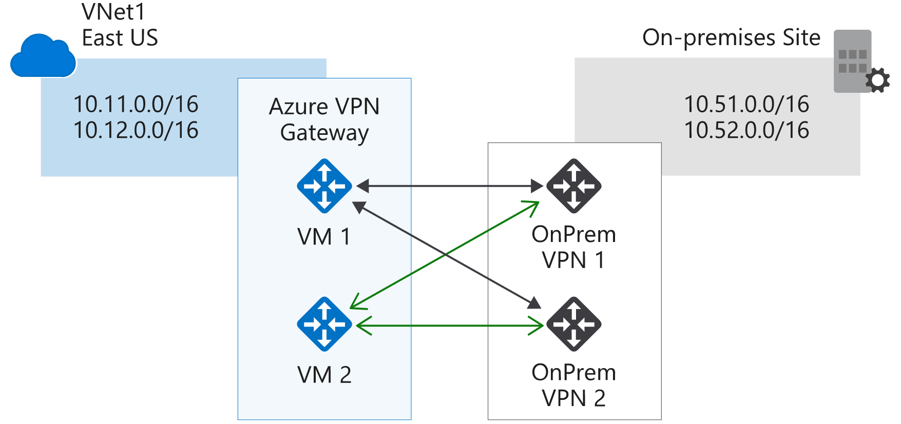

ExpressRoute failover
In high availability scenarios, where there's risk associated with an outage of an ExpressRoute circuit, you can also provision a VPN gateway which uses the internet as an alternative method of connectivity, thus ensuring there's always a connection to the Azure virtual networks.

Zone-redundant gateways
In regions that support availability zones, VPN and ExpressRoute gateways can be deployed in a zone-redundant configuration. This brings resiliency, scalability, and higher availability to virtual network gateways. Deploying gateways in Azure Availability Zones physically and logically separates gateways within a region, while protecting your on-premises network connectivity to Azure from zone-level failures. These require different gateway SKUs and leverage Standard public IP addresses instead of Basic public IP addresses.
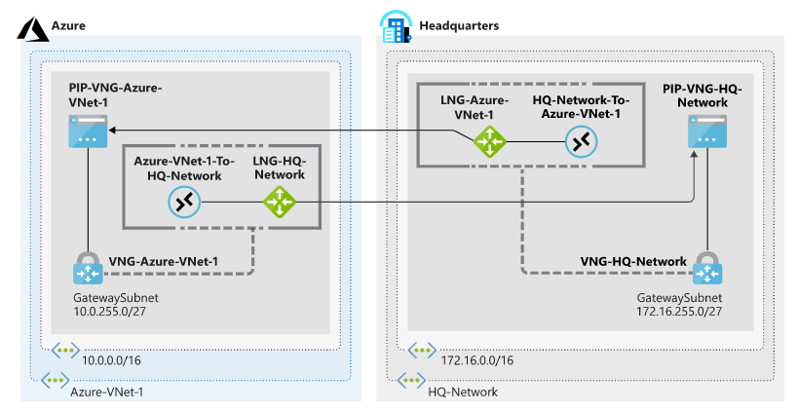

Create the Azure-side resources
  - Run the following command in Azure Cloud Shell to create the Azure-VNet-1 virtual network and the Services subnet.
    - az network vnet create \
    - --resource-group [sandbox resource group name] \
    - --name Azure-VNet-1 \
    - --address-prefixes 10.0.0.0/16 \
    - --subnet-name Services \
    - --subnet-prefixes 10.0.0.0/24
  - Run the following command in Cloud Shell to add the GatewaySubnet subnet to Azure-VNet-1.
    - az network vnet subnet create \
    - --resource-group [sandbox resource group name] \
    - --vnet-name Azure-VNet-1 \
    - --address-prefixes 10.0.255.0/27 \
    - --name GatewaySubnet
  - Run the following command in Cloud Shell to create the LNG-HQ-Network local network gateway.
    - az network local-gateway create \
    - --resource-group [sandbox resource group name] \
    - --gateway-ip-address 94.0.252.160 \
    - --name LNG-HQ-Network \
    - --local-address-prefixes 172.16.0.0/16

Create the simulated on-premises network with similar commands as above
Vnet- HQ-Network
Subnet – GatewaySubnet
Local-gateway - LNG-Azure-VNet-1

Create a site-to-site VPN gateway by using Azure CLI commands

Create the Azure-side VPN gateway
- Run the following command in Cloud Shell to create the PIP-VNG-Azure-VNet-1 public IP address.

az network public-ip create \
--resource-group [sandbox resource group name] \
--name PIP-VNG-Azure-VNet-1 \
--allocation-method Dynamic

- Run the following command in Cloud Shell to create the VNG-Azure-VNet-1 virtual network.
az network vnet create \
--resource-group [sandbox resource group name] \
--name VNG-Azure-VNet-1 \
--subnet-name GatewaySubnet
3) Run the following command in Cloud Shell to create the VNG-Azure-VNet-1 virtual network gateway.
az network vnet-gateway create \
--resource-group [sandbox resource group name] \
--name VNG-Azure-VNet-1 \
--public-ip-addresses PIP-VNG-Azure-VNet-1 \
--vnet VNG-Azure-VNet-1 \
--gateway-type Vpn \
--vpn-type RouteBased \
--sku VpnGw1 \
--no-wait

Next, you'll create a VPN gateway to simulate an on-premises VPN device. After that follow below steps
- Run the following Azure CLI command to check whether both virtual network gateways have been created. The initial state will show Updating. You want to see Succeeded on both VNG-Azure-VNet-1 and VNG-HQ-Network.
az network vnet-gateway list \
--resource-group [sandbox resource group name] \
--output table
2) Run the following command in Cloud Shell to retrieve the IPv4 address assigned to PIP-VNG-Azure-VNet-1 and store it in a variable.
PIPVNGAZUREVNET1=$(az network public-ip show \
--resource-group [sandbox resource group name] \
--name PIP-VNG-Azure-VNet-1 \
--query "[ipAddress]" \
--output tsv)
3) Run the following command in Cloud Shell to update the LNG-Azure-VNet-1 local network gateway so that it points to the public IP address attached to the VNG-Azure-VNet-1 virtual network gateway.
az network local-gateway update \
--resource-group [sandbox resource group name] \
--name LNG-Azure-VNet-1 \
--gateway-ip-address $PIPVNGAZUREVNET1
4) Run the following command in Cloud Shell to retrieve the IPv4 address assigned to PIP-VNG-HQ-Network and store it in a variable.
PIPVNGHQNETWORK=$(az network public-ip show \
--resource-group [sandbox resource group name] \
--name PIP-VNG-HQ-Network \
--query "[ipAddress]" \
--output tsv)
5) Run the following command in Cloud Shell to update the LNG-HQ-Network local network gateway so that it points to the public IP address attached to the VNG-HQ-Network virtual network gateway.
az network local-gateway update \
--resource-group [sandbox resource group name] \
--name LNG-HQ-Network \
--gateway-ip-address $PIPVNGHQNETWORK

Create the connections
You'll now complete the configuration by creating the connections from each VPN gateway to the local network gateway that contains the public IP address references for that gateway's remote network.
- Create the shared key to use for the connections. In the following command, replace <shared key> with a text string to use for the IPSec pre-shared key. The pre-shared key is a string of printable ASCII characters no longer than 128 characters. It cannot contain special characters, like hyphens and tildes. You'll use this pre-shared key on both connections.
- Remember that LNG-HQ-Network contains a reference to the IP address on your simulated on-premises VPN device. Run the following command in Cloud Shell to create a connection from VNG-Azure-VNet-1 to LNG-HQ-Network.
az network vpn-connection create \
--resource-group [sandbox resource group name] \
--name Azure-VNet-1-To-HQ-Network \
--vnet-gateway1 VNG-Azure-VNet-1 \
--shared-key $SHAREDKEY \
--local-gateway2 LNG-HQ-Network
3) Remember that LNG-Azure-VNet-1 contains a reference to the public IP address associated with the VNG-Azure-VNet-1 VPN gateway. This connection would normally be created from your on-premises device. Run the following command in Cloud Shell to create a connection from VNG-HQ-Network to LNG-Azure-VN
az network vpn-connection create \
--resource-group [sandbox resource group name] \
--name HQ-Network-To-Azure-VNet-1 \
--vnet-gateway1 VNG-HQ-Network \
--shared-key $SHAREDKEY \
--local-gateway2 LNG-Azure-VNet-1
Final topology


Connect your on-premises network to the Microsoft global network by using ExpressRoute

Connect your on-premises systems and users to Azure and Office 365 by using ExpressRoute for private, dedicated, and guaranteed throughput connectivity.

What is the Azure ExpressRoute service?

As part of the project for the finance company, you need to understand:
- What Azure ExpressRoute is.
- How ExpressRoute integrates with on-premises and Azure networks.
- The benefits that ExpressRoute provides compared to other site-to-site connectivity options.
- Whether ExpressRoute can provide the finance company with the best possible network performance.

ExpressRoute overview
Azure ExpressRoute lets you seamlessly extend your on-premises networks into the Microsoft cloud. This connection between your organization and Azure is dedicated and private. Establishing an ExpressRoute connection enables you to connect to Microsoft cloud services like Azure, Office 365, and Dynamics 365. Security is enhanced, connections are more reliable, latency is minimal, and throughput is greatly increased.

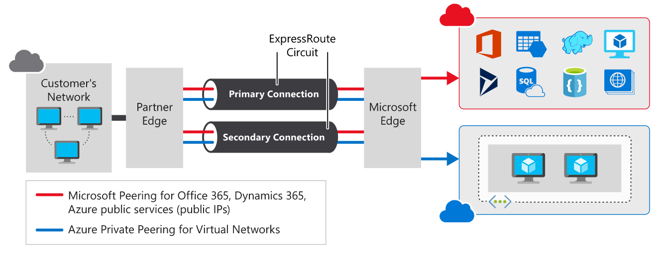

Features and benefits of ExpressRoute

Layer 3 connectivity
ExpressRoute provides Layer 3 (address-level) connectivity between your on-premises network and the Microsoft cloud through connectivity partners. These connections can be from a point-to-point, any-to-any network, or they can be virtual cross-connections through an exchange.

Built-in redundancy
Each connectivity provider uses redundant devices to ensure that connections established with Microsoft are highly available. You can configure multiple circuits to complement this feature. All redundant connections are configured with Layer 3 connectivity to meet SLAs.

Connectivity to Microsoft cloud services
ExpressRoute enables direct access to the following services in all regions:
- Microsoft Office 365
- Microsoft Dynamics 365
- Azure compute services, such as Azure Virtual Machines
- Azure cloud services, such as Azure Cosmos DB and Azure Storage

Across on-premises connectivity with ExpressRoute Global Reach
You can enable ExpressRoute Global Reach to exchange data across your on-premises sites by connecting your ExpressRoute circuits. For example, assume that you have a private datacenter in California connected to ExpressRoute in Silicon Valley. You have another private datacenter in Texas connected to ExpressRoute in Dallas. With ExpressRoute Global Reach, you can connect your private datacenters through two ExpressRoute circuits. Your cross-datacenter traffic will travel through the Microsoft network.

Dynamic routing
ExpressRoute uses the Border Gateway Protocol (BGP) routing protocol. BGP is used to exchange routes between on-premises networks and resources running in Azure. This protocol enables dynamic routing between your on-premises network and services running in the Microsoft cloud.

ExpressRoute connectivity models
ExpressRoute supports three models that you can use to connect your on-premises network to the Microsoft cloud:
- Cloud Exchange co-location
- Point-to-point Ethernet connection
- Any-to-any connection

  - CloudExchange co-location
Co-located providers can normally offer both Layer 2 and Layer 3 connections between your infrastructure, which might be located in the co-location facility, and the Microsoft cloud. For example, if your datacenter is co-located at a cloud exchange such as an internet service provider (ISP), you can request a virtual cross-connection to the Microsoft cloud.
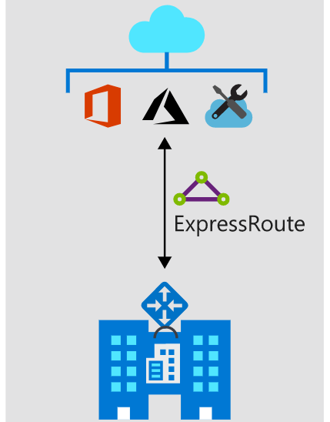

Point-to-point Ethernet connection
Point-to-point connections provide Layer 2 and Layer 3 connectivity between your on-premises site and Microsoft Azure. You can connect your offices or datacenters to Azure by using the point-to-point links. For example, if you have an on-premises datacenter, you can use a point-to-point Ethernet link to connect to Microsoft.
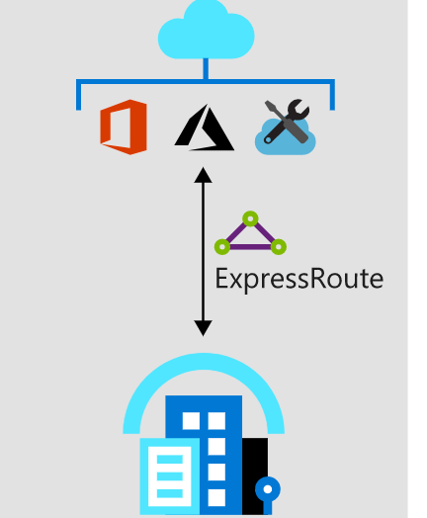

Any-to-any networks
With any-to-any connectivity, you can integrate your wide area network (WAN) with Microsoft Azure by providing connections to your offices and datacenters. Azure will integrate with your WAN connection to provide a seamless connection, just like you would have between your datacenter and any branch offices.

Security considerations
With ExpressRoute, your data doesn’t travel over the public internet, so it's not exposed to the potential risks associated with internet communications. ExpressRoute is a private connection from your on-premises infrastructure to your Azure infrastructure. Even if you have an ExpressRoute connection, DNS queries, certificate revocation list checking, and Azure Content Delivery Network requests are still sent over the public internet.

How Azure ExpressRoute works

Architecture of ExpressRoute
ExpressRoute is supported across all regions and locations. To implement ExpressRoute, you need to work with an ExpressRoute partner. The partner provides the edge service: an authorized and authenticated connection that operates through a partner-controlled router. The edge service is responsible for extending your network to the Microsoft cloud.
The partner sets up connections to an endpoint in an ExpressRoute location (implemented by a Microsoft edge router). These connections enable you to peer your on-premises networks with the virtual networks available through the endpoint. These connections are called circuits.
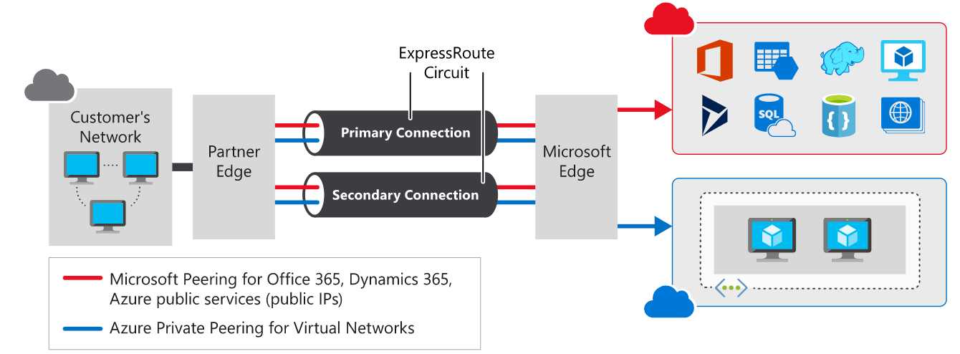

Prerequisites for ExpressRoute
Before you can connect to Microsoft cloud services by using ExpressRoute, you need to have:
- An ExpressRoute connectivity partner or cloud exchange provider that can set up a connection from your on-premises networks to the Microsoft cloud.
- An Azure subscription that is registered with your chosen ExpressRoute connectivity partner.
- An active Microsoft Azure account that can be used to request an ExpressRoute circuit.
- An active Office 365 subscription, if you want to connect to the Microsoft cloud and access Office 365 services.
ExpressRoute works by peering your on-premises networks with networks running in the Microsoft cloud. To support these peerings, ExpressRoute has a number of network and routing requirements.
- Ensure that BGP sessions for routing domains have been configured
- You or your providers need to translate the private IP addresses used on-premises to public IP addresses by using a NAT service.
- Reserve several blocks of IP addresses in your network for routing traffic to the Microsoft cloud.

Use private peering to connect to Azure IaaS and PaaS services deployed inside Azure virtual networks
Use Microsoft peering to connect to Azure PaaS services, Office 365 services, and Dynamics 365.

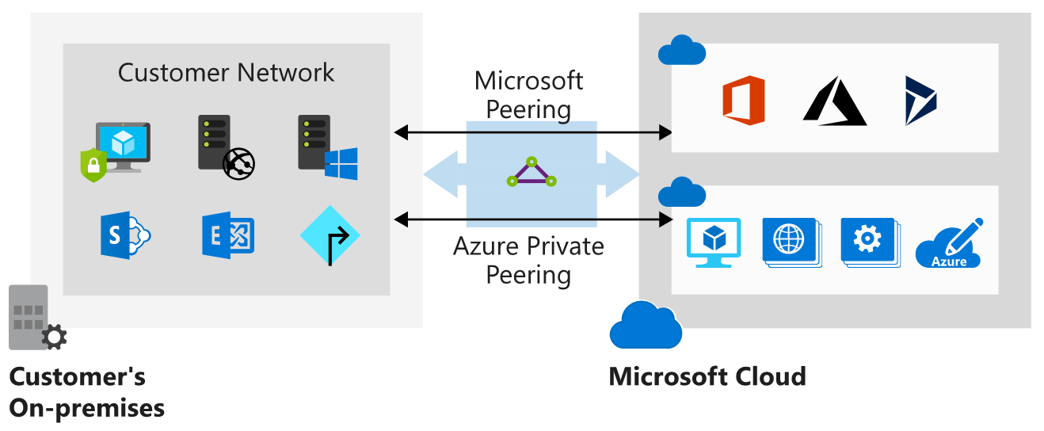

Create an ExpressRoute circuit and peering

Create a circuit
When you're using the Azure portal, select Create a resource > Networking > ExpressRoute. The Create ExpressRoute circuit page requires you to complete the following fields:
Circuit name , Provider (The ExpressRoute provider with which you've registered your subscription.) , Peering location (A location enabled by the ExpressRoute provider) , Bandwidth , SKU , Billing model , Subscription , Resource group , Location

Create a peering configuration
After the provider status is reported as Provisioned, you can configure the routing for the peerings. These steps apply only to circuits that are created with service providers who offer Layer 2 connectivity. For any circuits that operate at Layer 3, the provider might be able to configure the routing for you.

Configure private peering
You use private peering to connect your network to your virtual networks running in Azure. To configure private peering, you must provide the following information:
- Peer ASN. The autonomous system number for your side of the peering. This ASN can be public or private, and 16 bits or 32 bits.
- Primary subnet. This is the address range of the primary /30 subnet that you created in your network. You'll use the first IP address in this subnet for your router. Microsoft uses the second for its router.
- Secondary subnet. This is the address range of your secondary /30 subnet. This subnet provides a secondary link to Microsoft. The first two addresses are used to hold the IP address of your router and the Microsoft router.
- VLAN ID. This is the VLAN on which to establish the peering. The primary and secondary links will both use this VLAN ID.
- Shared key. This is an optional MD5 hash that's used to encode messages passing over the circuit.

Configure Microsoft peering
You use Microsoft peering to connect to Office 365 and its associated services. To configure Microsoft peering, you provide a peer ASN, a primary subnet address range, a secondary subnet address range, a VLAN ID, and an optional shared key as described for a private peering. You must also provide the following information:
- Advertised public prefixes. This is a list of the address prefixes that you use over the BGP session. These prefixes must be registered to you, and must be prefixes for public address ranges.
- Customer ASN. This is optional. It's the client-side autonomous system number to use if you are advertising prefixes that aren't registered to the peer ASN.
- Routing registry name. This name identifies the registry in which the customer ASN and public prefixes are registered.

Connect a virtual network to an ExpressRoute circuit
Before you can connect to a private circuit, you must create an Azure virtual network gateway by using a subnet on one of your Azure virtual networks. The virtual network gateway provides the entry point to network traffic that enters from your on-premises network. It directs incoming traffic through the virtual network to your Azure resources.
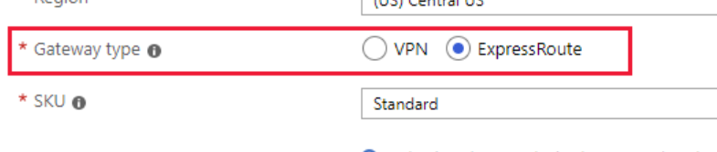
If you're using the Azure portal, you connect a peering to a virtual network gateway as follows:
- On the ExpressRoute circuit page for your circuit, select Connections.
- On the Connections page, select Add.
- On the Add connection page, give your connection a name, and then select your virtual network gateway. When the operation has finished, your on-premises network will be connected through the virtual network gateway to your virtual network in Azure. The connection will be made across the ExpressRoute connection.
In each ExpressRoute circuit, there are two connections from the connectivity provider to two different Microsoft edge routers. This configuration occurs automatically. It provides a degree of availability within a single location.

ExpressRoute Direct and FastPath
Microsoft also provides an ultra-high-speed option called ExpressRoute Direct. This service enables dual 100-Gbps connectivity.

When to use Azure ExpressRoute
Consider using the Azure ExpressRoute service in the following scenarios:
- Low-latency connectivity to services in the cloud. In these situations, eliminating or reducing the network overhead will have a significant impact on the performance of your applications.
- Accessing high-volume systems in the cloud that consume or produce massive volumes of data quickly. ExpressRoute can move data around rapidly, with high reliability.
- Consuming Microsoft Cloud Services, such as Office 365 and Dynamics 365. ExpressRoute is especially useful if your organization has a large number of users who need to access these services concurrently.
- Organizations that have migrated large-scale on-premises systems to Azure. Using ExpressRoute helps ensure that the results of the migrations are seamless for on-premises clients. They should notice no drop in performance. They might even experience some improvement if the previous on-premises systems were restricted by network bandwidth.
- Situations where data should not traverse the public internet for security reasons.
- Large datacenters, with a high number of users and systems accessing SaaS offerings.

Benefits of using ExpressRoute

Predictable performance

Data privacy for your traffic

High-throughput, low-latency connections

Availability and connectivity

Alternatives to ExpressRoute

Site-to-site VPN
An Azure site-to-site VPN connection enables you to connect your on-premises network to Azure over an IPsec tunnel to build a hybrid network solution.

Point-to-site VPN
With point-to-site VPN, you can establish a secure connection to a network from individual computers located on-premises. This solution is useful for someone who wants to connect to Azure from remote locations such as a home or customer site. Point-to-site is useful if you have only a few clients that need to connect to a virtual network.

Azure ExpressRoute vs. site-to-site and point-to-site VPN connections
Connection | Azure services supported | Bandwidth | Protocols | Typical use case
Virtual network, point-to-site | Azure IaaS and PaaS services (through private endpoints) | Based on the gateway SKU | Active/passive | Dev, test, and lab environments for cloud services and virtual machines.
Virtual network, site-to-site | Azure IaaS and PaaS services (through private endpoints) | Typically < 1 Gbps aggregate | Active/passive | Dev, test, and lab environments. Small-scale production workloads and virtual machines.
ExpressRoute | Azure IaaS and PaaS services, Microsoft Office 365 services | 50 Mbps up to 10 Gbps (100 Gbps for ExpressRoute Direct) | Active/active | Enterprise-class and mission-critical workloads. Big data solutions.

Secure and isolate access to Azure resources by using network security groups and service endpoints
Network security groups and service endpoints help you secure your virtual machines and Azure services from unauthorized network access

Use network security groups to control network access

Network security groups
Network security groups filter network traffic to and from Azure resources. Network security groups contain security rules that you configure to allow or deny inbound and outbound traffic. You can use network security groups to filter traffic between VMs or subnets, both within a virtual network and from the internet.

Network security group assignment and evaluation
Network security groups are assigned to a network interface or a subnet. When you assign a network security group to a subnet, the rules apply to all network interfaces in that subnet. You can restrict traffic further by associating a network security group to the network interface of a VM.
When you apply network security groups to both a subnet and a network interface, each network security group is evaluated independently. Inbound traffic is first evaluated by the network security group applied to the subnet, and then by the network security group applied to the network interface. Conversely, outbound traffic from a VM is first evaluated by the network security group applied to the network interface, and then by the network security group applied to the subnet.
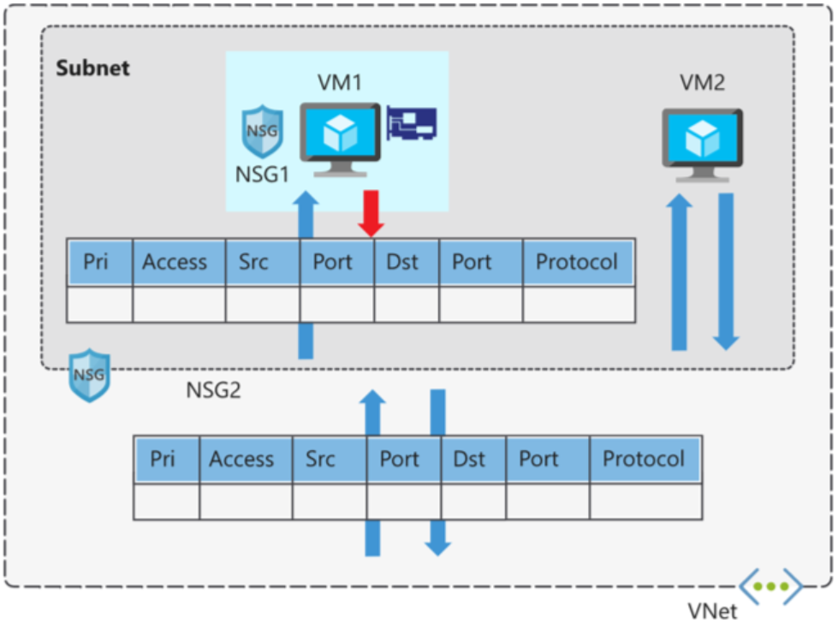
Each subnet and network interface can have one network security group applied to it. Network security groups support TCP, UDP, and ICMP, and operate at Layer 4 of the OSI model.

Security rules
A network security group contains one or more security rules. Configure security rules to either allow or deny traffic.
Rules have several properties:
Property | Explanation
Name | A unique name within the network security group.
Priority | A number between 100 and 4096.
Source and destination | Any, or an individual IP address, classless inter-domain routing (CIDR) block (10.0.0.0/24, for example), service tag, or app security group.
Protocol | TCP, UDP, or Any.
Direction | Whether the rule applies to inbound, or outbound traffic.
Port range | An individual port or range of ports.
Action | Allow or deny the traffic.
Network security group security rules are evaluated by priority, using the 5-tuple information (source, source port, destination, destination port, and protocol) to allow or deny the traffic. When the conditions for a rule match the device configuration, rule processing stops.
The rule with priority 150 is processed before the rule with priority 200.

Default security rules
When you create a network security group, Azure creates several default rules. These default rules can't be changed, but can be overridden with your own rules.
The default rules for inbound traffic are:
DEFAULT SECURITY RULES
Priority | Rule name | Description
65000 | AllowVnetInbound | Allow inbound coming from any VM to any VM within the subnet.
65001 | AllowAzureLoadBalancerInbound | Allow traffic from the default load balancer to any VM within the subnet.
65500 | DenyAllInBound | Deny traffic from any external source to any of the VMs.
The default rules for outbound traffic are:
DEFAULT SECURITY RULES
Priority | Rule name | Description
65000 | AllowVnetOutbound | Allow outbound going from any VM to any VM within the subnet.
65001 | AllowInternetOutbound | Allow outbound traffic going to the internet from any VM.
65500 | DenyAllOutBound | Deny traffic from any internal VM to a system outside the virtual network.

Augmented security rules
You use augmented security rules for network security groups to simplify the management of large numbers of rules. Augmented security rules also help when you need to implement more complex network sets of rules. Augmented rules let you add the following options into a single security rule:
- Multiple IP addresses
- Multiple ports
- Service tags
- App security groups

Service tags
You can restrict access to many services. Microsoft manages the service tags (you can't create your own). Some examples of the tags are:
- VirtualNetwork - Represents all virtual network addresses anywhere in Azure, and in your on-premises network if you're using hybrid connectivity.
- AzureLoadBalancer - Denotes Azure's infrastructure load balancer. The tag translates to the virtual IP address of the host (168.63.129.16) where Azure health probes originate.
- Internet - Represents anything outside the virtual network address that is publicly reachable, including resources that have public IP addresses. One such resource is the Web Apps feature of Azure App Service.
- AzureTrafficManager - Represents the IP address for Azure Traffic Manager.
- Storage - Represents the IP address space for Azure Storage. You can specify whether traffic is allowed or denied. You can also specify if access is allowed only to a specific region, but you can't select individual storage accounts.
- SQL - Represents the address for Azure SQL Database, Azure Database for MySQL, Azure Database for PostgreSQL, and Azure Synapse Analytics services. You can specify whether traffic is allowed or denied, and you can limit to a specific region.
- AppService - Represents address prefixes for Azure App Service.

App security groups
App security groups let you configure network security for resources used by specific apps. You can group VMs logically, no matter what their IP address or subnet assignment.
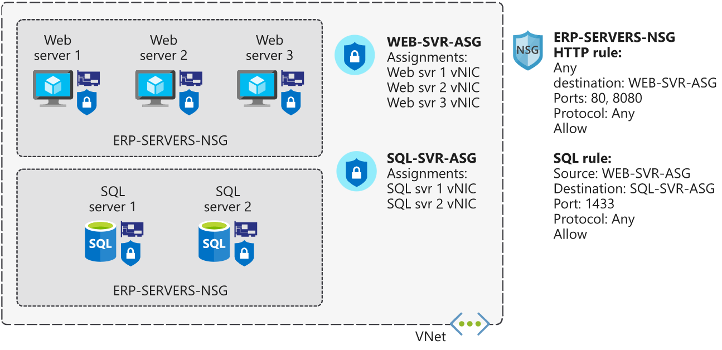

When to use network security groups
As a best practice, you should always use network security groups to help protect your networked assets against unwanted traffic. Network security groups give you granular control access over the network layer, without the potential complexity of setting security rules for every VM or virtual network.
Create network security groups
az network nsg create \
--resource-group $rg \
--name ERP-SERVERS-NSG
az network nsg rule create \
--resource-group $rg \
--nsg-name ERP-SERVERS-NSG \
--name AllowSSHRule \
--direction Inbound \
--priority 100 \
--source-address-prefixes '*' \
--source-port-ranges '*' \
--destination-address-prefixes '*' \
--destination-port-ranges 22 \
--access Allow \
--protocol Tcp \
--description "Allow inbound SSH"
az network nsg rule create \
--resource-group $rg \
--nsg-name ERP-SERVERS-NSG \
--name httpRule \
--direction Inbound \
--priority 150 \
--source-address-prefixes 10.0.1.4 \
--source-port-ranges '*' \
--destination-address-prefixes 10.0.0.4 \
--destination-port-ranges 80 \
--access Deny \
--protocol Tcp \
--description "Deny from DataServer to AppServer on port 80"
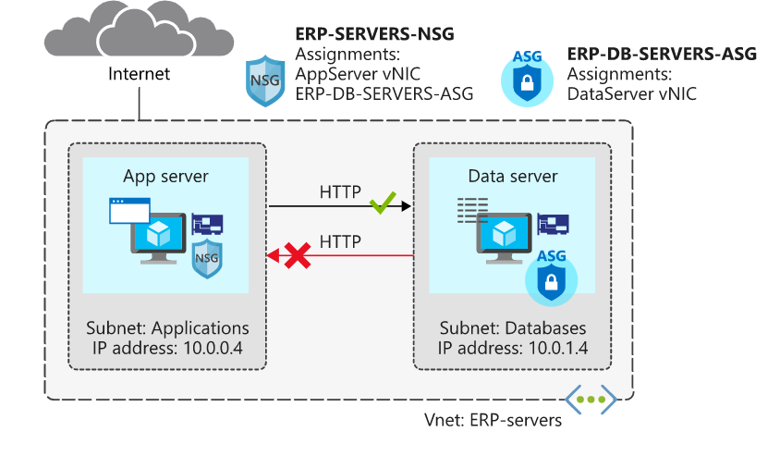
az network asg create \
--resource-group $rg \
--name ERP-DB-SERVERS-ASG
az network nic ip-config update \
--resource-group $rg \
--application-security-groups ERP-DB-SERVERS-ASG \
--name ipconfigDataServer \
--nic-name DataServerVMNic \
--vnet-name ERP-servers \
--subnet Databases
az network nsg rule update \
--resource-group $rg \
--nsg-name ERP-SERVERS-NSG \
--name httpRule \
--direction Inbound \
--priority 150 \
--source-address-prefixes "" \
--source-port-ranges '*' \
--source-asgs ERP-DB-SERVERS-ASG \
--destination-address-prefixes 10.0.0.4 \
--destination-port-ranges 80 \
--access Deny \
--protocol Tcp \
--description "Deny from DataServer to AppServer on port

Secure network access to PaaS services with virtual network service endpoints

Virtual network service endpoints
Use virtual network service endpoints to extend your private address space in Azure by providing a direct connection to your Azure services. Service endpoints let you secure your Azure resources to only your virtual network. Service traffic will remain on the Azure backbone, and doesn't go out to the internet.
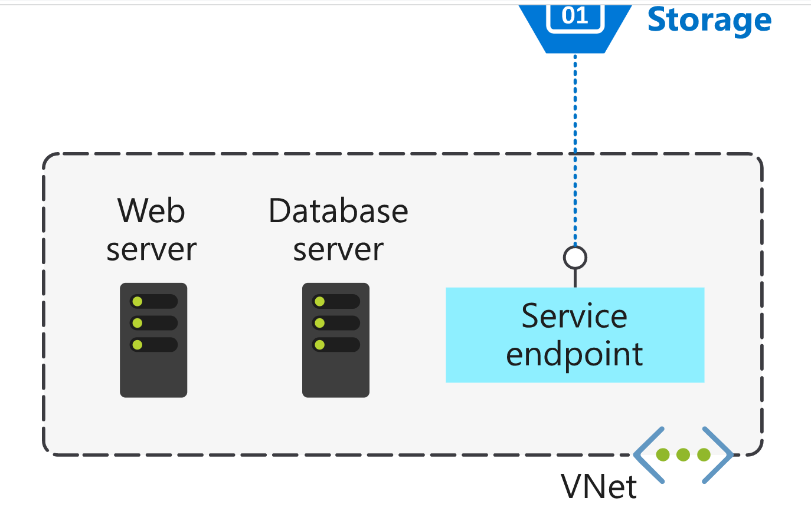
Azure service endpoints are available for many services, such as:
- Azure Storage
- Azure SQL Database
- Azure Cosmos DB
- Azure Key Vault
- Azure Service Bus
- Azure Data Lake
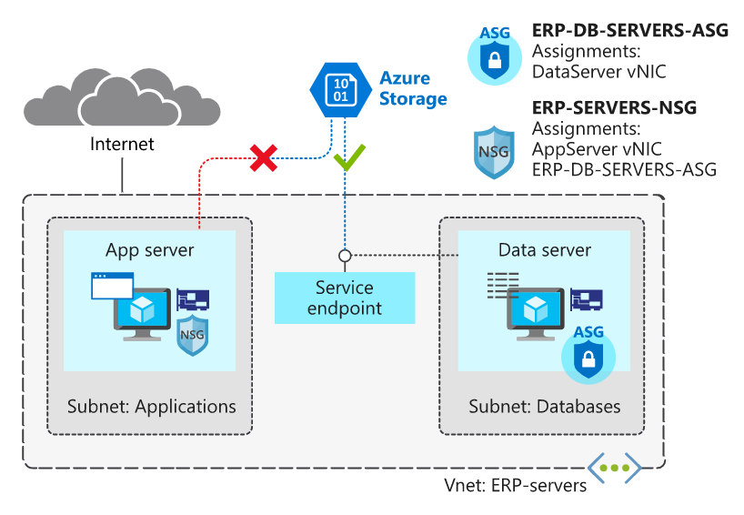
az network vnet subnet update \
--vnet-name ERP-servers \
--resource-group $rg \
--name Databases \
--service-endpoints Microsoft.Storage
az storage account update \
--resource-group $rg \
--name $STORAGEACCT \

--default-action Deny

az storage account network-rule add \
--resource-group $rg \
--account-name $STORAGEACCT \
--vnet-name ERP-servers \

--subnet Databases

Distribute your services across Azure virtual networks and integrate them by using virtual network peering

You can use virtual network peering to directly connect Azure virtual networks. When you use peering to connect virtual networks, virtual machines (VMs) in these networks can communicate with each other as if they were in the same network.
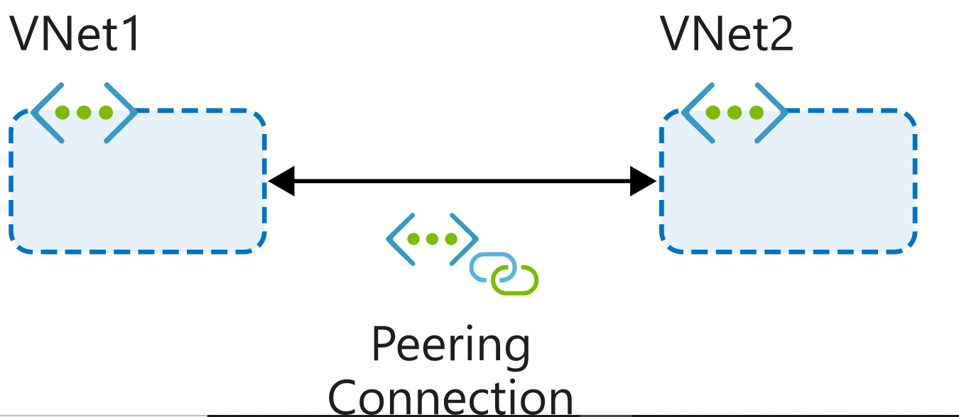
The two types of peering connections are created in the same way:
- Virtual network peering connects virtual networks in the same Azure region, such as two virtual networks in North Europe.
- Global virtual network peering connects virtual networks that are in different Azure regions, such as a virtual network in North Europe and a virtual network in West Europe.

Reciprocal connections
When you create a virtual network peering connection in only one virtual network to connect to a peer in another network, you're not connecting the networks together. To connect the networks by using virtual network peering, you have to create connections in each virtual network.

Cross-subscription virtual network peering
You can use virtual network peering even when both virtual networks are in different subscriptions. This might be necessary for mergers and acquisitions or to connect virtual networks in subscriptions that different departments manage. Virtual networks can be in different subscriptions, and the subscriptions can use the same or different Azure Active Directory tenants.

Transitivity
Virtual network peering is nontransitive. Only virtual networks that are directly peered can communicate with each other. The virtual networks can't communicate with the peers of their peers.

Gateway transit
You can configure transitive connections on-premises if you use virtual network gateways as transit points. Using gateway transit, you can enable on-premises connectivity without deploying virtual network gateways to all your virtual networks. This method might reduce cost and complexity. By using gateway peering, you can configure a single virtual network as a hub network. Connect this hub network to your on-premises datacenter and share its virtual network gateway with peers.

Overlapping address spaces
IP address spaces of connected networks within Azure and between Azure and your on-premises system can't overlap. This is also true for peered virtual networks. Keep this rule in mind when you're planning your network design. In any networks you connect through virtual network peering, VPN, or ExpressRoute, assign different address spaces that don't overlap.
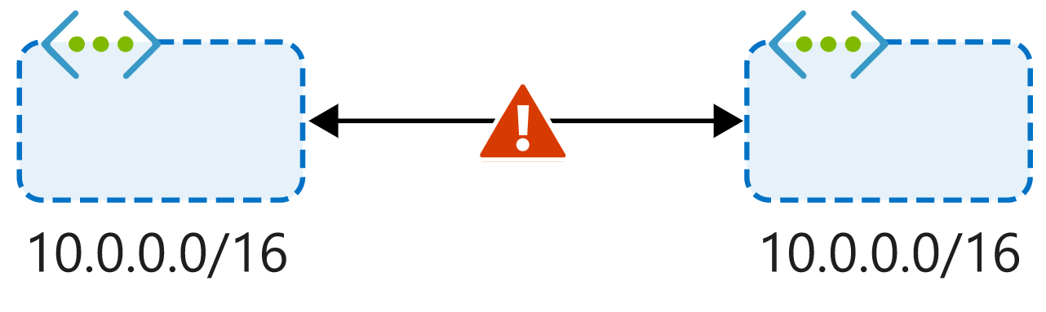

Alternative connectivity methods
Virtual network peering is the least complex way to connect virtual networks. Other methods focus primarily on connectivity between on-premises and Azure networks rather than connections between virtual networks.

When to choose virtual network peering
Virtual network peering can be a great way to enable network connectivity between services that are in different virtual networks. Because it's easy to implement and deploy, and it works well across regions and subscriptions, virtual network peering should be your first choice when you need to integrate Azure virtual networks.
In Cloud Shell, run the following command to create the peering connection between the SalesVNet and MarketingVNet virtual networks. This command also permits virtual network access across this peering connection.
az network vnet peering create \
--name SalesVNet-To-MarketingVNet \
--remote-vnet MarketingVNet \
--resource-group [sandbox resource group name] \
--vnet-name SalesVNet \
--allow-vnet-access
Run the following command to create a reciprocal connection from MarketingVNet to SalesVNet. This step completes the connection between these virtual networks.
az network vnet peering create \
--name MarketingVNet-To-SalesVNet \
--remote-vnet SalesVNet \
--resource-group [sandbox resource group name] \
--vnet-name MarketingVNet \
--allow-vnet-access
az network vnet peering list \
--resource-group [sandbox resource group name] \
--vnet-name ResearchVNet \
--output table
ssh -o StrictHostKeyChecking=no azureuser@<MarketingVM private IP>

Enhance your service availability and data locality by using Azure Traffic Manager
Your customers require 24x7 availability of your company's streaming music application. Cloud services in one region might become unavailable because of technical issues, such as planned maintenance or scheduled security updates. In these scenarios, your company wants to have a failover endpoint so your customers can continue to access its services. To manage routing traffic and to handle these situations, you've decided to implement Azure Traffic Manager.
Traffic Manager uses DNS to direct clients to a specific service endpoint IP address based on the rules of the traffic routing method that's used. Clients connect directly to the selected endpoint. Traffic Manager isn't a proxy or gateway. Traffic Manager doesn't see the traffic that passes between the clients and the service; it just gives clients the IP address of where they need to go.

Traffic Manager endpoints
An endpoint is the destination location that is returned to the client. You configure each application deployment as an 'endpoint' in Traffic Manager. When Traffic Manager receives a DNS request, it chooses an available endpoint to return in the DNS response. There are three types of endpoint supported by Traffic Manager:
- Azure endpoints are used for services hosted in Azure. These can be services like Azure App Service, as well as public IP resources that are associated with load balancers or virtual machines.
- External endpoints are used for IPv4/IPv6 addresses, FQDNs, or for services hosted outside Azure that can either be on-premises or with a different hosting provider.
- Nested endpoints are used to combine Traffic Manager profiles to create more flexible traffic-routing schemes to support the needs of larger, more complex deployments.

Weighted routing
Choose weighted when you want to distribute traffic across a set of endpoints, either evenly, or based on different weights. The weight is an integer from 1 to 1,000.

Performance routing
If you have endpoints in different geographic locations, you can use performance routing to send users to the endpoint that has the best performance for the user.

Geographic routing
With the geographic routing method, users are directed to specific endpoints based on where their DNS query originates. Using this method enables you to geo-fence content to specific user regions

Multivalue routing
You can use the multivalue routing method to get multiple healthy endpoints in a single DNS query response. The caller can make client-side retries with other endpoints if an endpoint is unresponsive. This pattern can increase the availability of a service and reduce the latency associated with a new DNS query to obtain a healthy endpoint.

Subnet routing
This method maps the set of user IP address ranges to specific endpoints within a Traffic Manager profile. When a request is received, the endpoint returned will be the one mapped for that request's source IP address. For example, using subnet routing, a customer can route all requests from their corporate office to a different endpoint, where they might be testing an internal-only version of the app. Another scenario is if you want to provide a different experience to users who connect from a specific ISP (for example, to block users from a specific ISP).

Priority routing
The Traffic Manager profile contains a prioritized list of service endpoints. By default, Traffic Manager sends all traffic to the primary (highest-priority) endpoint. If the primary endpoint isn't available, Traffic Manager routes the traffic to the second endpoint. If both the primary and secondary endpoints are not available, the traffic goes to the third endpoint, and so on.

Enable automatic failover by using priority routing

az network traffic-manager profile create \
--resource-group Sandbox resource group \
--name TM-MusicStream-Priority \
--routing-method Priority \
--unique-dns-name TM-MusicStream-Priority-$RANDOM

az deployment group create \
--resource-group Sandbox resource group \
--template-uri https://raw.githubusercontent.com/MicrosoftDocs/mslearn-distribute-load-with-traffic-manager/master/azuredeploy.json \
--parameters password="$(head /dev/urandom | tr -dc A-Za-z0-9 | head -c 32)"
az network traffic-manager endpoint create \
--resource-group Sandbox resource group \
--profile-name TM-MusicStream-Priority \
--name "Primary-WestUS" \
--type azureEndpoints \
--priority 1 \

--target-resource-id $WestId

f) Improve application scalability and resiliency by using Azure Load Balancer

Distribute traffic with Azure Load Balancer
Azure Load Balancer is a service you can use to distribute traffic across multiple virtual machines. Use Load Balancer to scale applications and create high availability for your virtual machines and services. Load balancers use a hash-based distribution algorithm. By default, a five-tuple hash is used to map traffic to available servers. The hash is made from the following elements:
- Source IP: The IP address of the requesting client.
- Source port: The port of the requesting client.
- Destination IP: The destination IP of the request.
- Destination port: The destination port of the request.
- Protocol type: The specified protocol type, TCP or UDP.
With Load Balancer, you can use availability sets and availability zones to ensure that virtual machines are always available
Configuration | Service level agreement (SLA) | Information
Availability set | 99.95% | Protection from hardware failures within datacenters
Availability zone | 99.99% | Protection from entire datacenter failure

Select the right Load Balancer product
Two products are available when you create a load balancer in Azure: basic load balancers and standard load balancers.
Basic load balancers allow:
- Port forwarding
- Automatic reconfiguration
- Health probes
- Outbound connections through source network address translation (SNAT)
- Diagnostics through Azure Log Analytics for public-facing load balancers
Basic load balancers can be used only with availability sets.
Standard load balancers support all of the basic load balancer features. They also allow:
- HTTPS health probes
- Availability zones
- Diagnostics through Azure Monitor, for multidimensional metrics
- High availability (HA) ports
- Outbound rules
- A guaranteed SLA (99.99% for two or more virtual machines)

Internal and external load balancers
An external load balancer operates by distributing client traffic across multiple virtual machines. An external load balancer permits traffic from the internet. The traffic might come from browsers, mobile apps, or other sources. In a healthcare organization, the balancer distributes the load of all the browsers that run the client healthcare application.
An internal load balancer distributes a load from internal Azure resources to other Azure resources. For example, if you have front-end web servers that need to call business logic that's hosted on multiple middle-tier servers, you can distribute that load evenly by using an internal load balancer. No traffic is allowed from internet sources. In a healthcare organization, a load balancer distributes a load across the internal application tier.

Distribution modes
Five-tuple hash. The default distribution mode for Load Balancer is a five-tuple hash. The tuple is composed of source IP, source port, destination IP, destination port, and protocol type. Because the source port is included in the hash and the source port changes for each session, clients might be directed to a different virtual machine for each session.
Source IP affinity. This distribution mode is also known as session affinity or client IP affinity. To map traffic to the available servers, the source IP affinity mode uses a two-tuple hash (from the source IP address and destination IP address) or a three-tuple hash (from the source IP address, destination IP address, and protocol type). The hash ensures that requests from a specific client are always sent to the same virtual machine behind the load balancer.
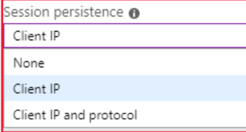
Create a new public IP address.
az network public-ip create \
--resource-group [sandbox resource group name] \
--allocation-method Static \
--name myPublicIP
Create the load balancer.
az network lb create \
--resource-group [sandbox resource group name] \
--name myLoadBalancer \
--public-ip-address myPublicIP \
--frontend-ip-name myFrontEndPool \
--backend-pool-name myBackEndPool
To allow the load balancer to monitor the status of the healthcare portal, create a health probe.
az network lb probe create \
--resource-group [sandbox resource group name] \
--lb-name myLoadBalancer \
--name myHealthProbe \
--protocol tcp \
--port 80
Now you need a load balancer rule that's used to define how traffic is distributed to the VMs. You define the front-end IP configuration for the incoming traffic and the back-end IP pool to receive the traffic, along with the required source and destination port.
az network lb rule create \
--resource-group [sandbox resource group name] \
--lb-name myLoadBalancer \
--name myHTTPRule \
--protocol tcp \
--frontend-port 80 \
--backend-port 80 \
--frontend-ip-name myFrontEndPool \
--backend-pool-name myBackEndPool \
--probe-name myHealthProbe
Connect the VMs to the back-end pool by updating the network interfaces you created in the script to use the back-end pool information.
az network nic ip-config update \
--resource-group [sandbox resource group name] \
--nic-name webNic1 \
--name ipconfig1 \
--lb-name myLoadBalancer \
--lb-address-pools myBackEndPool

az network nic ip-config update \
--resource-group [sandbox resource group name] \
--nic-name webNic2 \
--name ipconfig1 \
--lb-name myLoadBalancer \
--lb-address-pools myBackEndPool

You can configure an internal load balancer in almost the same way as an external load balancer, but with these differences:
- When you create the load balancer, for the Type value, select Internal. When you select this setting, the front-end IP address of the load balancer isn't exposed to the internet.
- Assign a private IP address instead of a public IP address for the front end of the load balancer.
- Place the load balancer in the protected virtual network that contains the virtual machines you want to handle the requests.
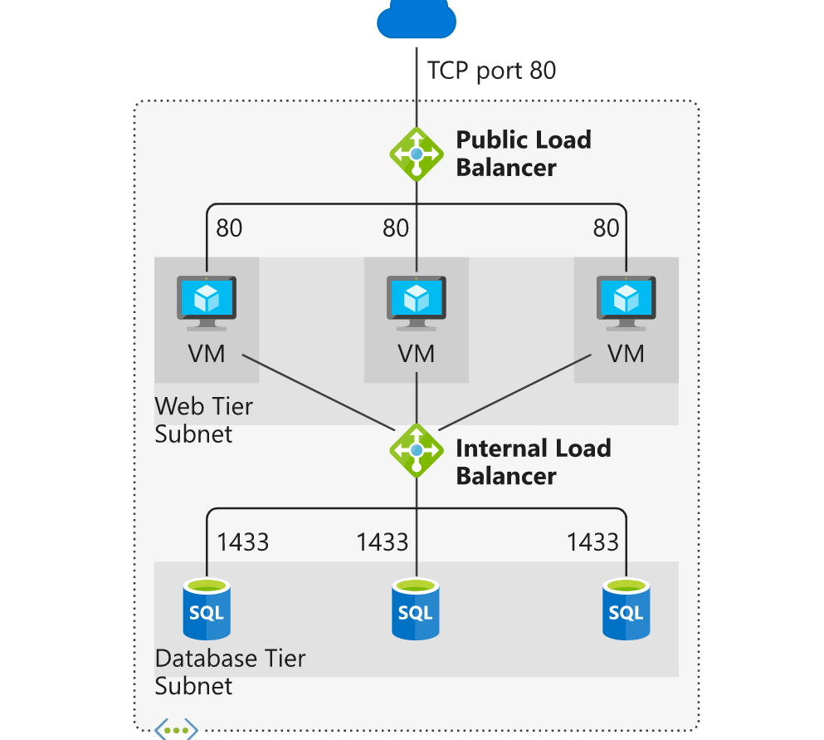

Load balance your web service traffic with Application Gateway

Route traffic with Application Gateway

Application Gateway manages the requests that client applications can send to a web app. Application Gateway routes traffic to a pool of web servers based on the URL of a request. This is known as application layer routing.
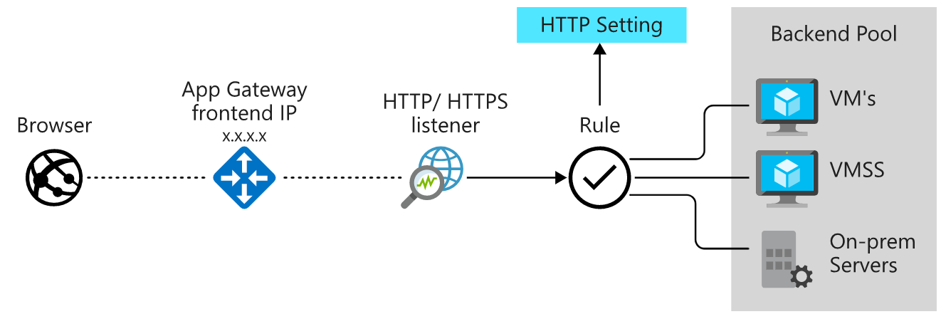

How Application Gateway routes requests
Clients send requests to your web apps to the IP address or DNS name of the gateway. The gateway routes requests to a selected web server in the back-end pool, using a set of rules configured for the gateway to determine where the request should go.
There are two primary methods of routing traffic, path-based routing and multiple site hosting. Let's take a look at the capabilities for each.

Path-based routing
Path-based routing enables you to send requests with different paths in the URL to a different pool of back-end servers. For example, you could direct requests with the path /video/* to a back-end pool containing servers that are optimized to handle video streaming, and direct /images/* requests to a pool of servers that handle image retrieval.
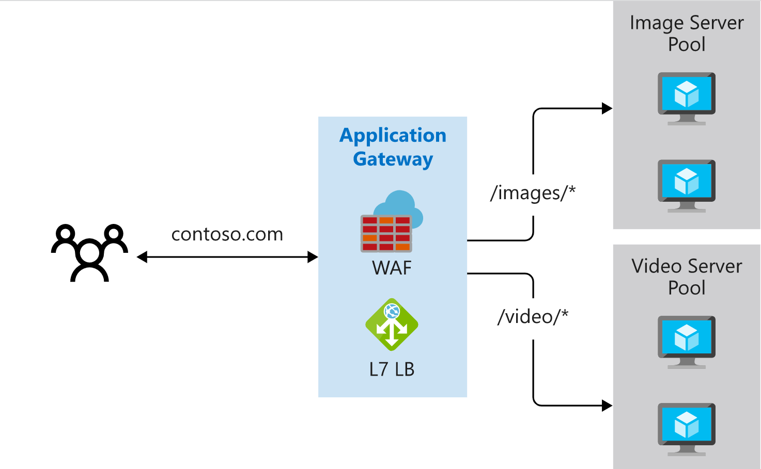

Multiple site hosting
Multiple site hosting enables you to configure more than one web application on the same application gateway instance. In a multi-site configuration, you register multiple DNS names (CNAMEs) for the IP address of the Application Gateway, specifying the name of each site. Application Gateway uses separate listeners to wait for requests for each site. Each listener passes the request to a different rule, which can route the requests to servers in a different back-end pool. For example, you could configure Application Gateway to direct all requests for http://contoso.com to servers in one back-end pool, and requests for http://fabrikam.com to another back-end pool. The following diagram shows this configuration.

Other routing capabilities
Along with path-based routing and multiple site hosting, there are a few additional capabilities when routing with Application Gateway.
- Redirection - Redirection can be used to another site, or from HTTP to HTTPS.
- Rewrite HTTP headers - HTTP headers allow the client and server to pass additional information with the request or the response.
- Custom error pages - Application Gateway allows you to create custom error pages instead of displaying default error pages. You can use your own branding and layout using a custom error page.

Load balancing in Application Gateway
Application Gateway will automatically load balance requests sent to the servers in each back-end pool using a round-robin mechanism. However, you can configure session stickiness, if you need to ensure that all requests for a client in the same session are routed to the same server in a back-end pool.
Load-balancing works with the OSI Layer 7 routing implemented by Application Gateway routing, which means that it load balances requests based on the routing parameters (host names and paths) used by the Application Gateway rules. In comparison, other load balancers, such as Azure Load Balancer, function at the OSI Layer 4 level, and distribute traffic based on the IP address of the target of a request.
Operating at OSI Layer 7 enables load balancing to take advantage of the other features that Application Gateway provides. These features include:
- Support for the HTTP, HTTPS, HTTP/2 and WebSocket protocols.
- A web application firewall to protect against web application vulnerabilities.
- End-to-end request encryption.
- Autoscaling, to dynamically adjust capacity as your web traffic load changes.

Application Gateway creation and configuration

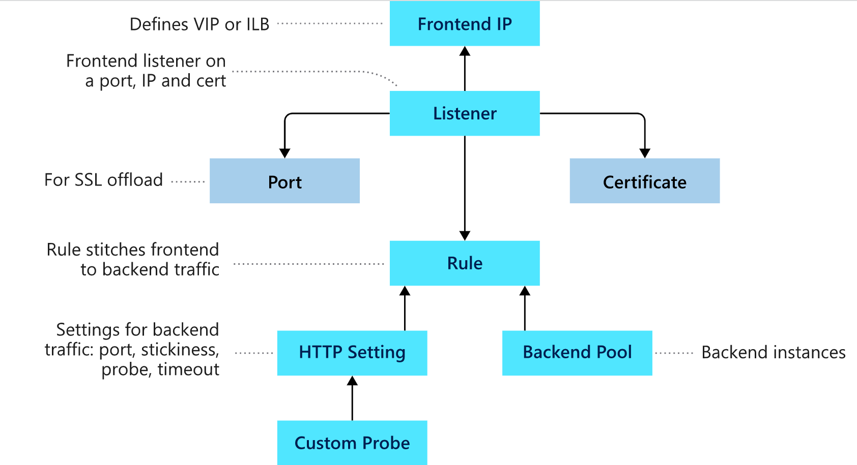

Front-end IP address
Client requests are received through a front-end IP address. You can configure Application Gateway to have a public IP address, a private IP address, or both. Application Gateway can't have more than one public and one private IP address.

Listeners
Application Gateway uses one or more listeners to receive incoming requests. A listener accepts traffic arriving on a specified combination of protocol, port, host, and IP address. Each listener routes requests to a back-end pool of servers following routing rules that you specify. A listener can be Basic or Multi-site.

Routing rules
A routing rule binds a listener to the back-end pools. A rule specifies how to interpret the hostname and path elements in the URL of a request, and direct the request to the appropriate back-end pool. A routing rule also has an associated set of HTTP settings.
- Protocol (HTTP or HTTPS).
- Session stickiness, to pass all requests in a client session to the same web server rather than distributing them across servers with load balancing.
- Connection draining, to enable the graceful removal of servers from a back-end pool.
- Request timeout period, in seconds.
- Health probes, specifying a probe URL, time out periods, and other parameters used to determine whether a server in the back-end pool is available.

Back-end pools
A back-end pool references a collection of web servers. You provide the IP address of each web server and the port on which it listens for requests when configuring the pool. Each pool can specify a fixed set of virtual machines, a virtual machine scale-set, an app hosted by Azure App Services, or a collection of on-premises servers. Each back-end pool has an associated load balancer that distributes work across the pool

Web application firewall
The web application firewall (WAF) is an optional component that handles incoming requests before they reach a listener. The web application firewall checks each request for many common threats, based on the Open Web Application Security Project (OWASP). These include:
- SQL-injection
- Cross-site scripting
- Command injection
- HTTP request smuggling
- HTTP response splitting
- Remote file inclusion
- Bots, crawlers, and scanners
- HTTP protocol violations and anomalies

Health probes
Health probes are an important part in assisting the load balancer to determine which servers are available for load balancing in a back-end pool. Application Gateway uses a health probe to send a request to a server. If the server returns an HTTP response with a status code between 200 and 399, the server is deemed healthy.

Application Gateway network requirements

Application Gateway options
You can create an Application Gateway on the Standard tier or the WAF tier. You also have a choice of three sizes with varying performance, pricing, and scalability: Small, Medium, and Large.

Create and configure a gateway
You can create and configure Application Gateway using the Azure portal, Azure PowerShell, or the Azure CLI. For Azure CLI, use the az network application-gateway create command to create a new gateway. If you prefer PowerShell, you can use the New-AzApplicationGateway cmdlet. You can also use the Azure portal to perform most operations.

Configure the network for Application Gateway
  - To create the private subnet required by Application Gateway,
az network vnet subnet create
  - To create a public IP address and DNS label for Application Gateway, run the following command.
az network public-ip create

Create an application gateway
- Create an application gateway named vehicleAppGateway
az network application-gateway create \
- To find the private IP addresses of webServer1 and webServer2, run the following commands.
az vm list-ip-addresses \
- Next, we'll add the back-end pools for each web site
az network application-gateway address-pool create \
- To create a back-end pool for the license renewal site running on App Service
az network application-gateway address-pool create
- For port 80, create a front-end port.
az network application-gateway frontend-port create \
- To handle requests on port 80, create the listener.
az network application-gateway http-listener create \

Add a health probe
- Create a health probe that tests the availability of a web server.
az network application-gateway probe create \
- Next, to use the health probe you created, create the HTTP Settings for the gateway.
az network application-gateway http-settings create \

Configure path-based routing
- To create the path map for the vmPool, run the following command.
az network application-gateway url-path-map create \
- To create the path map rule for the appServicePool, run the following command.
az network application-gateway url-path-map rule create \
- Now, create a new routing rule using the path map you created.
az network application-gateway rule create \

Manage and control traffic flow in your Azure deployment with routes

Azure routing
Network traffic in Azure is automatically routed across Azure subnets, virtual networks, and on-premises networks. This routing is controlled by system routes, which are assigned by default to each subnet in a virtual network. With these system routes, any Azure virtual machine that is deployed to a virtual network can communicate with all other Azure virtual machines in subnets in that network. These virtual machines are also potentially accessible from on-premises through a hybrid network or the internet.
Every subnet has the following default system routes:
AZURE ROUTING
Address prefix | Next hop type
Unique to the virtual network | Virtual network
0.0.0.0/0 | Internet
10.0.0.0/8 | None
172.16.0.0/12 | None
192.168.0.0/16 | None
100.64.0.0/10 | None

The Next hop type column shows the network path taken by traffic sent to each address prefix. The path can be one of the following hop types:
- Virtual network: A route is created in the address prefix. The prefix represents each address range created at the virtual-network level. If multiple address ranges are specified, multiple routes are created for each address range.
- Internet: The default system route 0.0.0.0/0 routes any address range to the internet, unless you override Azure's default route with a custom route.
- None: Any traffic routed to this hop type is dropped and doesn't get routed outside the subnet. By default, the following IPv4 private-address prefixes are created: 10.0.0.0/8, 172.16.0.0/12, and 192.168.0.0/16. The prefix 100.64.0.0/10 for a shared address space is also added. None of these address ranges are globally routable.
Within Azure, there are additional system routes. Azure will create these routes if the following capabilities are enabled:
- Virtual network peering
- Service chaining
- Virtual network gateway
- Virtual network service endpoint

Virtual network peering and service chaining
Virtual network peering and service chaining let virtual networks within Azure be connected to one another. With this connection, virtual machines can communicate with each other within the same region or across regions. This communication in turn creates additional routes within the default route table. Service chaining lets you override these routes by creating user-defined routes between peered networks.
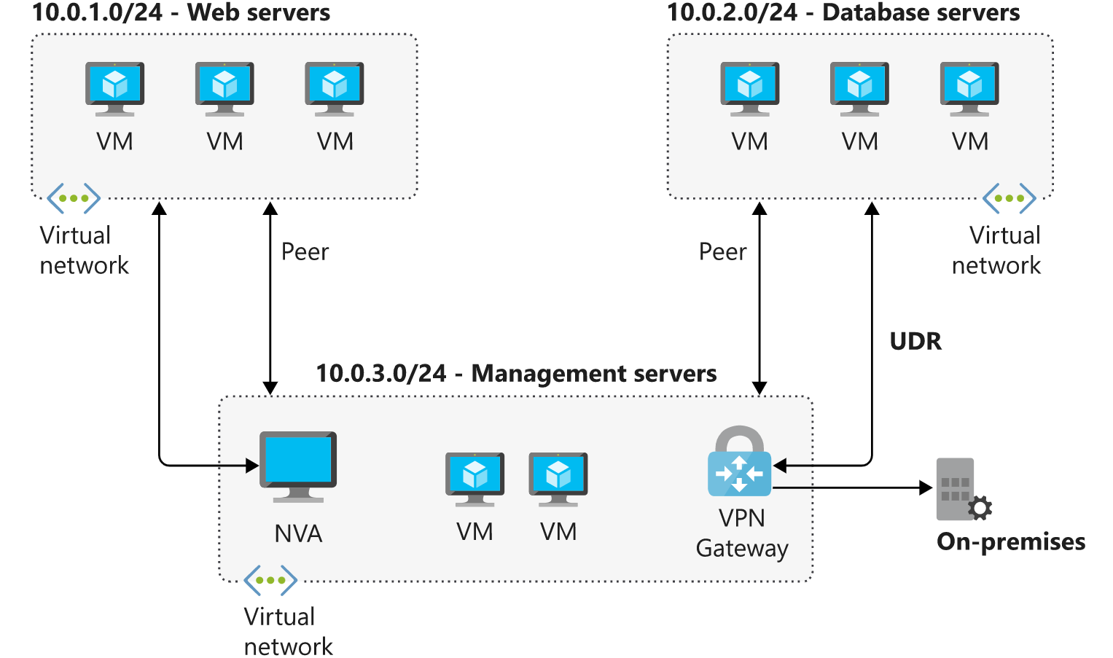

Virtual network gateway
Use a virtual network gateway to send encrypted traffic between Azure and on-premises over the internet and to send encrypted traffic between Azure networks. A virtual network gateway contains routing tables and gateway services.
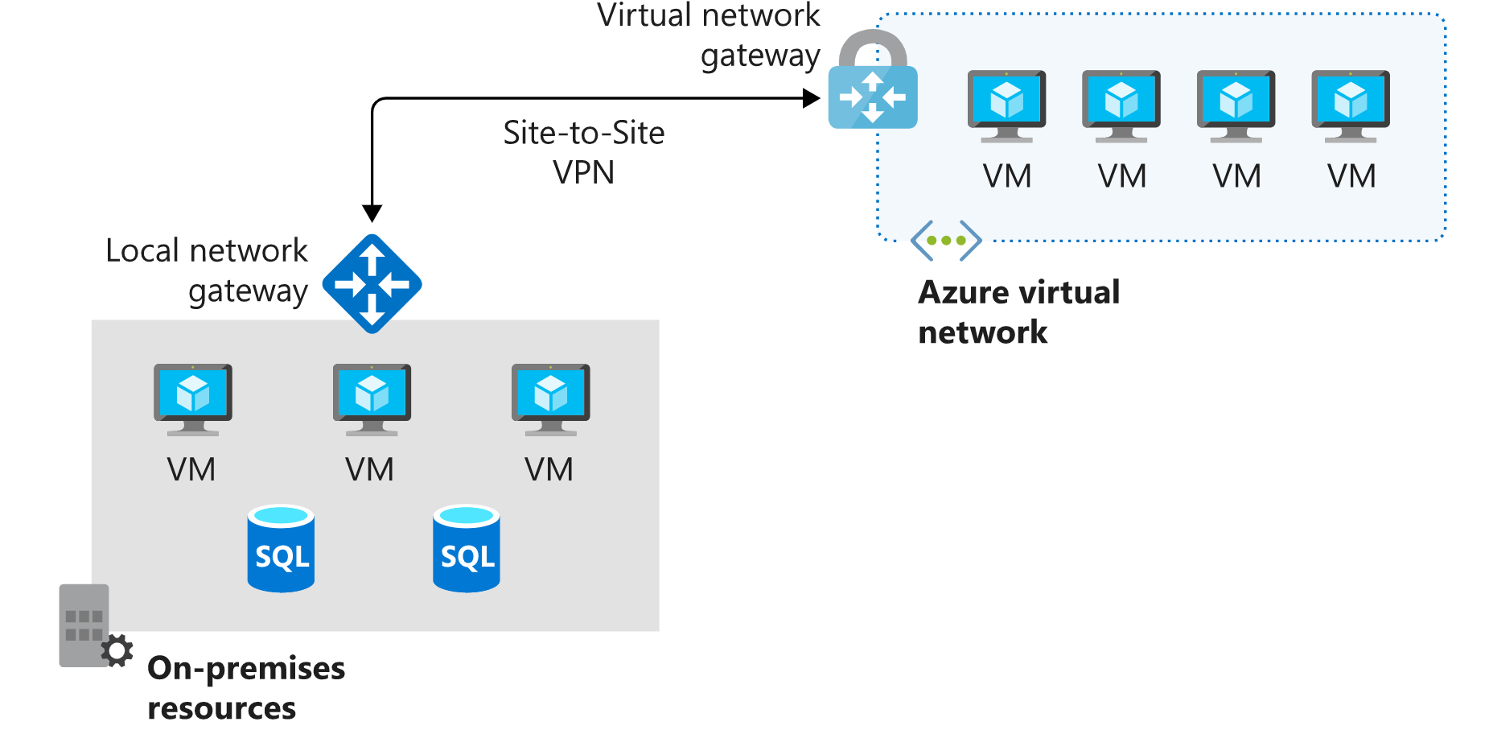

Virtual network service endpoint
Virtual network endpoints extend your private address space in Azure by providing a direct connection to your Azure resources. This connection restricts the flow of traffic: your Azure virtual machines can access your storage account directly from the private address space and deny access from a public virtual machine. As you enable service endpoints, Azure creates routes in the route table to direct this traffic.

Custom routes
System routes might make it easy for you to quickly get your environment up and running. But there are many scenarios in which you'll want to more closely control the traffic flow within your network. For example, you might want to route traffic through an NVA or through a firewall from partners and others. This control is possible with custom routes.

You have two options for implementing custom routes: create a user-defined route or use Border Gateway Protocol (BGP) to exchange routes between Azure and on-premises networks.

User-defined routes
You use a user-defined route to override the default system routes so that traffic can be routed through firewalls or NVAs.
For example, you might have a network with two subnets and want to add a virtual machine in the perimeter network to be used as a firewall. You create a user-defined route so that traffic passes through the firewall and doesn't go directly between the subnets.
When creating user-defined routes, you can specify these next hop types:
- Virtual appliance: A virtual appliance is typically a firewall device used to analyze or filter traffic that is entering or leaving your network. You can specify the private IP address of a NIC attached to a virtual machine so that IP forwarding can be enabled. Or you can provide the private IP address of an internal load balancer.
- Virtual network gateway: Use to indicate when you want routes for a specific address to be routed to a virtual network gateway. The virtual network gateway is specified as a VPN for the next hop type.
- Virtual network: Use to override the default system route within a virtual network.
- Internet: Use to route traffic to a specified address prefix that is routed to the internet.
- None: Use to drop traffic sent to a specified address prefix.
With user-defined routes, you can't specify the next hop type VirtualNetworkServiceEndpoint, which indicates virtual network peering.

Border gateway protocol
A network gateway in your on-premises network can exchange routes with a virtual network gateway in Azure by using BGP. BGP is the standard routing protocol that is normally used to exchange routing and information among two or more networks. BGP is used to transfer data and information between different host gateways like on the internet or between autonomous systems.
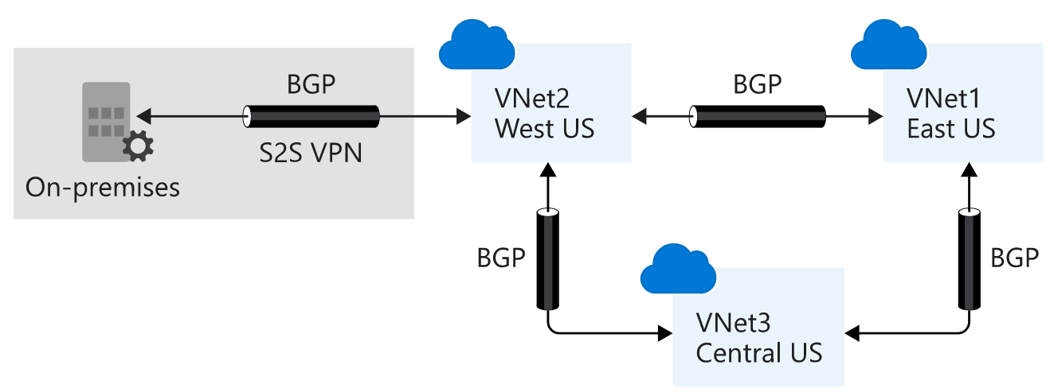

Route selection and priority
If multiple routes are available in a route table, Azure uses the route with the longest prefix match. For example, if a message is sent to the IP address 10.0.0.2, but two routes are available with the 10.0.0.0/16 and 10.0.0.0/24 prefixes, Azure selects the route with the 10.0.0.0/24 prefix because it's more specific.
If multiple routes share the same address prefix, Azure selects the route based on its type in the following order of priority:
- User-defined routes
- BGP routes
- System routes
In this exercise, you'll create the route table, custom route, and subnets. You'll then associate the route table with a subnet.
- In Azure Cloud Shell, run the following command to create a route table.
az network route-table create \
--name publictable \
--resource-group [sandbox resource group name] \
--disable-bgp-route-propagation false
2) Run the following command in Cloud Shell to create a custom route
az network route-table route create \
--route-table-name publictable \
--resource-group [sandbox resource group name] \
--name productionsubnet \
--address-prefix 10.0.1.0/24 \
--next-hop-type VirtualAppliance \
--next-hop-ip-address 10.0.2.4

Create a virtual network and subnets

Associate the route table with the public subnet
az network vnet subnet update \
--name publicsubnet \
--vnet-name vnet \
--resource-group [sandbox resource group name] \
--route-table publictable

What is an NVA?
A network virtual appliance (NVA) is a virtual appliance that consists of various layers like:
- a firewall
- a WAN optimizer
- application-delivery controllers
- routers
- load balancers
- IDS/IPS
- Proxies

You can deploy NVAs chosen from providers in Azure Marketplace. Such providers include Check Point, Barracuda, Sophos, WatchGuard, and SonicWall. You can use an NVA to filter traffic inbound to a virtual network, to block malicious requests, and to block requests made from unexpected resources.

Network virtual appliance
Network virtual appliances or NVAs are virtual machines that control the flow of network traffic by controlling routing. You typically use them to manage traffic flowing from a perimeter-network environment to other networks or subnets.
An NVA often includes various protection layers like:
- a firewall
- a WAN optimizer
- application-delivery controllers
- routers
- load balancers
- proxies
- an SD-WAN edge
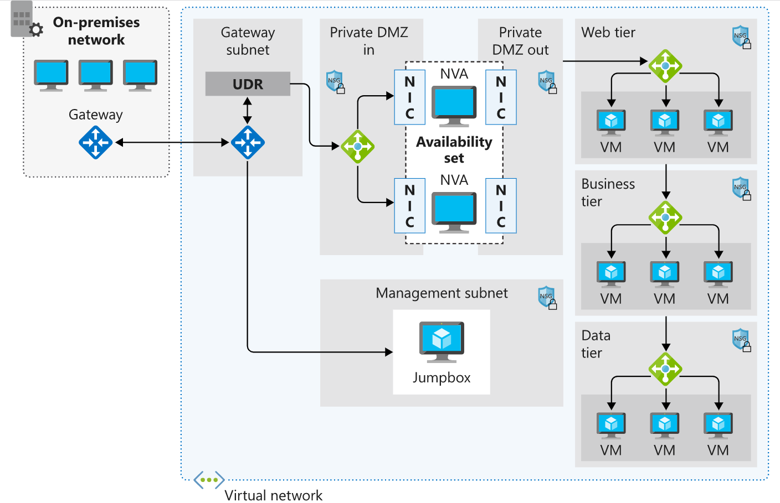
With the microsegmentation approach, you can create dedicated subnets for the firewall and then deploy web applications and other services in other subnets. All traffic is routed through the firewall and inspected by the NVAs. You enable forwarding on the virtual-appliance network interfaces to pass traffic that is accepted by the appropriate subnet.

User-defined routes
For most environments, the default system routes already defined by Azure are enough to get the environments up and running. But in certain cases you should create a routing table and add custom routes. Examples include:
- Access to the internet via on-premises network using forced tunneling.
- Using virtual appliances to control traffic flow.

Design an IP addressing schema for your Azure deployment

Network IP addressing and integration

On-premises IP addressing
A typical on-premises network design includes these components:
- Routers
- Firewalls
- Switches
- Network segmentation

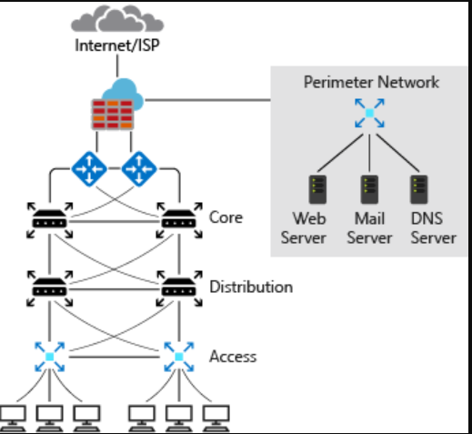

Azure IP addressing
In a typical Azure network design, we usually have these components:
- Virtual networks
- Subnets
- Network security groups
- Firewalls
- Load balancers

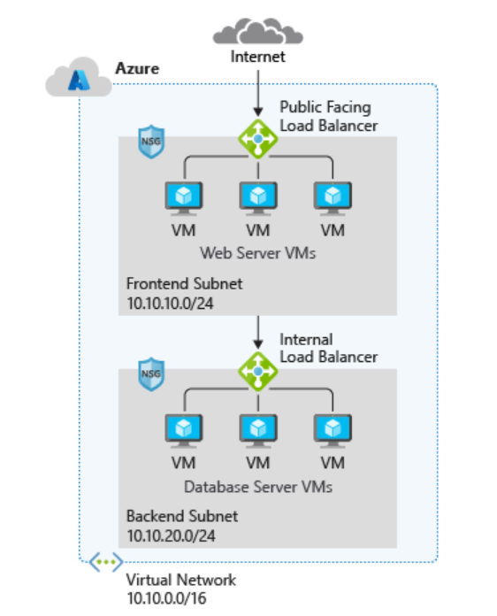

The Azure network does not follow the typical on-premises hierarchical network design. The Azure network provides the ability to scale up and scale down infrastructure based on demand.

Basic properties of Azure virtual networks

By default, all subnets in an Azure virtual network can communicate with each other. However, you can use a network security group to deny communication between subnets. The smallest subnet that is supported uses a /29 subnet mask. The largest supported subnet uses a /8 subnet mask.

Integrate Azure with on-premises networks
Before you start integrating Azure with on-premises networks, it's important to identify the current private IP address scheme used in the on-premises network. There can be no IP address overlap for interconnected networks.

Public and private IP addressing in Azure

IP address types
In Azure, you can use two types of IP addresses:
- Public IP addresses
- Private IP addresses
Both types of IP addresses can be allocated in one of two ways:
- Dynamic
- Static
Let's take a closer look at how the IP address types work together.

Public IP addresses
Use a public IP address for public-facing services. A public address can be either static or dynamic. A public IP address can be assigned to a VM, an internet-facing load balancer, a VPN gateway, or an application gateway.
- Dynamic public IP addresses are assigned addresses that can change over the lifespan of the Azure resource. The dynamic IP address is allocated when you create or start a VM. The IP address is released when you stop or delete the VM.

Static public IP addresses are assigned addresses that won't change over the lifespan of the Azure resource. To ensure that the IP address for the resource remains the same, you can set the allocation method to static.

SKUs for public IP addresses

For public IP addresses, there are two SKUs to choose from: Basic and Standard.

By default, Basic SKU IP addresses:
- Are open. Network security groups are recommended but optional for restricting inbound or outbound traffic.
- Are available for inbound only traffic.
- Are available when using instance meta data service (IDMS).
- Don't support Availability Zones.
- Don't support routing preferences.

By default, Standard SKU IP addresses:
- Always use static allocation.
- Are secure, and thus closed to inbound traffic. You must enable inbound traffic by using a network security group.
- Are zone-redundant; and optionally zonal (they can be created zonal and guaranteed in a specific availability zone).
- Can be assigned to network interfaces, Standard public load balancers, application gateways, or VPN gateways.
- Can be utilized with the routing preference to enable more granular control of how traffic is routed between Azure and the Internet.
- Can be used as anycast frontend IPs for cross-region load balancers

Private IP addresses
Private IP addresses are used for communication within an Azure Virtual Network, including virtual networks and your on-premises networks. Private IP addresses can be set to dynamic (DHCP lease) or static (DHCP reservation).
Dynamic private IP addresses are assigned through a DHCP lease and can change over the lifespan of the Azure resource.
Static private IP addresses are assigned through a DHCP reservation and don't change throughout the lifespan of the Azure resource. Static private IP addresses persist if a resource is stopped or deallocated.

Plan IP addressing for your networks

Here are two of the questions you might ask to discover the requirements:
- How many devices do you have on the network?
- How many devices are you planning to add to the network in the future?
When your network expands, you don't want to redesign the IP address scheme. Here are some other questions you could ask:
- Based on the services running on the infrastructure, what devices do you need to separate?
- How many subnets do you need?
- How many devices per subnet will you have?
- How many devices are you planning to add to the subnets in future?
- Are all subnets going to be the same size?
- How many subnets do you want or plan to add in future?

Design a hybrid network architecture on Azure

On-premises network integration on Azure

With an Azure virtual network, you can:
- Connect virtual machines to the internet.
- Provide secure communications between Azure resources that are hosted in various datacenters and regions.
- Isolate and manage Azure resources.
- Connect to on-premises computers.
- Manage network traffic.

Work with hybrid networks on Azure

What is a hybrid network architecture?
Hybrid network is a term that's used when two different network topologies combine to form a single cohesive network. With Azure, a hybrid network represents the merging or combining of an on-premises network with an Azure virtual network. It allows the continued use of your existing infrastructure while giving you all the benefits of cloud-based computing and access.
There are several reasons why you might want to adopt a hybrid network solution. The two most common are:
- To migrate from a pure on-premises network to a pure cloud-based network.
- To extend your on-premises network and resources to support the cloud services.
Whatever your motivations for adding cloud services to your infrastructure, there are several architectures to consider. We covered ExpressRoute in the preceding unit. The other architectures are:
- Azure VPN Gateway
- ExpressRoute with VPN failover
- Hub-spoke network topology

Azure VPN Gateway
Azure VPN Gateway, a virtual network gateway service, allows site-to-site and point-to-site VPN connectivity between your on-premises network and Azure.
A VPN or virtual private network is a well-established, well-understood network architecture.
VPN Gateway uses your existing connection to the internet. However, all communication is encrypted using the Internet Key Exchange (IKE) and Internet Protocol Security (IPsec) protocols. You can have only one virtual network gateway per virtual network.
- PolicyBased: Uses an IPsec tunnel to encrypt data packets. Configuration of the policy uses address prefixes that are drawn from your Azure virtual network and your on-premises network.
- RouteBased: Uses the routing or IP forwarding tables to route data packets to the correct tunnel. Each tunnel encrypts and decrypts all packets.

Site-to-site
All site-to-site gateway connections use an IPsec/IKE VPN tunnel to create a connection between Azure and your on-premises network. For a site-to-site connection to work, you'll need an on-premises VPN device with a publicly accessible IP address.
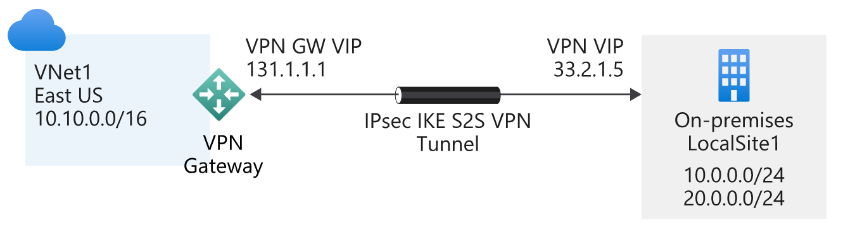

Point-to-site
A point-to-site gateway connection creates a secured connection between an individual device and your Azure virtual network. This gateway type is suited to remote workers; for example, users attending a conference or working from home. A point-to-site connection doesn't require a dedicated on-premises VPN device.
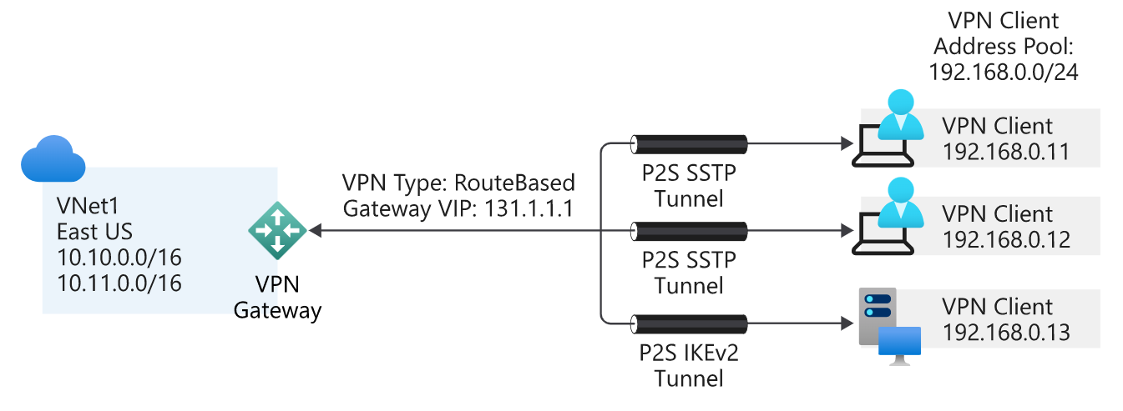

Benefits
Here are some of the benefits of using a VPN connection:
- It's a well-known technology, easy to configure and maintain.
- All data traffic is encrypted.
- It's better suited to lighter data-traffic loads.

Considerations
When you're evaluating the use of this hybrid architecture, consider the following points:
- A VPN connection uses the internet.
- Potential latency issues might exist, depending on bandwidth size and usage.
- Azure supports a maximum bandwidth of 1.25 Gbps.
- For site-to-site connections, you need a local VPN device.

ExpressRoute with VPN failover
One of the guarantees of using ExpressRoute is that it provides a high level of availability. Each ExpressRoute circuit comes with dual ExpressRoute gateways. However, even with this level of resiliency built into the Azure side of the network, connectivity might be interrupted. One way to remedy this situation, and maintain connectivity, is to provide a VPN failover service.

Hub-spoke network topology
The hub-spoke network topology allows you to structure the workloads that are carried out by your servers. It uses a single virtual network as the hub, which is also connected to your on-premises network through either VPN or ExpressRoute. The spokes are other virtual networks that are peered with the hub. Each spoke can be assigned specific workloads, and the hub is used for shared services.
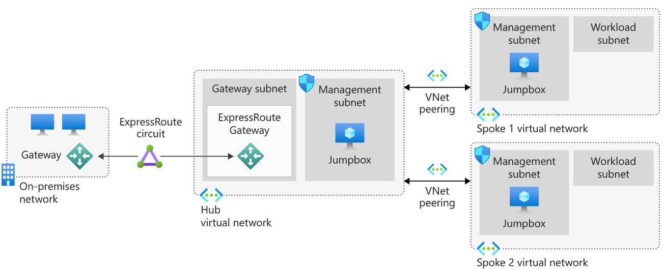

Benefits
Implementing a hub-spoke architecture has the following benefits:
- The use of sharing and centralized services on the hub might reduce the need for duplication on the spokes, which can reduce costs.
- Subscription limits are overcome by peering virtual networks.
- The hub-spoke model allows for the separation of organizational work areas into dedicated spokes, such as SecOps, InfraOps, and DevOps.

Hybrid networking capability matrix
To show what you've learned in this unit and to help you choose between the two connectivity types, we've built a capability matrix. The following table lists the key features for each method, the supported bandwidths, the resiliency model, typical use cases, and associated SLAs.
HYBRID NETWORKING CAPABILITY MATRIX
Capability | VPN Gateway | ExpressRoute
Azure services support | Azure Cloud Services and Azure Virtual Machines | Microsoft Cloud Platform
Bandwidth | Up to 10 Gbps | Up to 10 Gbps or 100 Gbps (direct)
Protocol | SSTP or IPsec | Direct over VLAN or MPLS
Routing | Static or dynamic | Border Gateway Protocol (BGP)
Connection resiliency | Active-passive or active-active | Active-passive or active-active
Use case | Prototyping, dev, test, labs, RDC, and small production workloads | Access to all Azure services, enterprise-grade, supporting critical large-scale workloads
SLA | 99.95-99.99% | 99.95%

Centralize your core services by using hub and spoke Azure virtual network architecture

In this module, you'll look at a hub-spoke topology in Azure that allows for growth and flexibility, planning and designing virtual networks, and helping to secure your architectural design. The final design will provide for isolation of resources, have a low administrative overhead, and allow communication from on-premises resources.

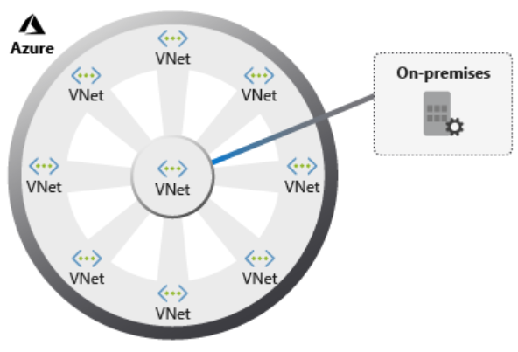
Implementing a hub and spoke architecture can have the following benefits:
- A centrally managed connection to your on-premises environment.
- Integration of separate working environments into a central location for shared services.
- Traffic routing through the central hub, so workloads can be managed centrally.
Hub-spoke topologies offer several business benefits:
- Increased business agility by standardizing on network connections. Organizations can adapt to changing markets, adding a new branch in a different geopolitical region, or a new business channel, as spokes.
- Liability reduction by maintaining a consistent architecture. As the business grows, or traffic volumes increase, it's simple to add more systems.
- Greater visibility into the business, with data flowing through the same place. The hub is the core of the business and provides the foundations for deeper business insights, as it processes every piece of information belonging to the organization.
- A single location in which to share centralized services by multiple workloads. This enables you to minimize redundant resources and the effort required to manage them.
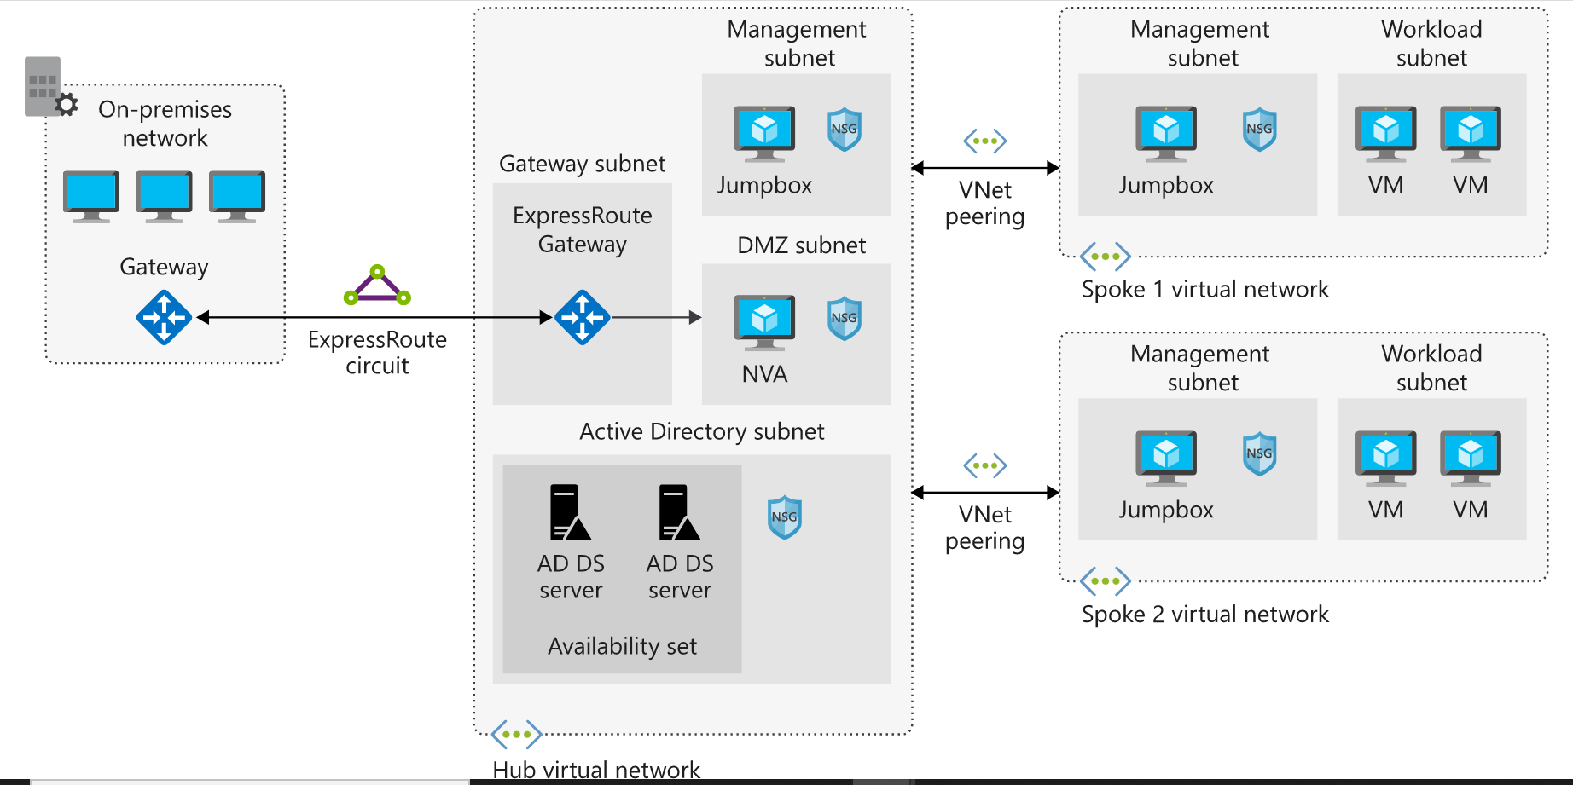
The components included in this architecture are:
- Azure Virtual Network: Azure virtual networks are a representation of your own IT network. They're contained within the cloud, logically isolating dedicated organizational resources in your subscriptions.
- Azure VPN Gateway: VPN Gateway is the bridge between your on-premises network and Azure. VPN gateways are a special type of Virtual Network gateway that sends encrypted traffic between the two networks over the internet.
- Azure ExpressRoute: ExpressRoute is a service in Azure that allows you to extend on-premises networks over a private connection.

Plan virtual networks in Azure

Virtual networks enable:
- External connections to the internet.
- Communication between different internal Azure resources.
- Isolation of those resources.
- Connections to on-premises computers.
- Network traffic management.

here are several considerations for virtual networks:
- Segmentation: It's important to consider potential isolation of traffic into different subnets or virtual networks, or into separate subscriptions.
- Security: Use NSGs and network virtual appliances to filter network traffic to and from resources in a virtual network.
- Connectivity: You can connect a virtual network to other virtual networks by using virtual network peering, or to your on-premises networks by using ExpressRoute or an Azure VPN Gateway.
- Routing: Azure virtual networks automatically create routing tables within each subnet, and add default system routes to the tables. Custom routes allow you to override these default system routes. With custom routes, you can direct traffic through network virtual appliances to provide enhanced security and filtering capabilities.

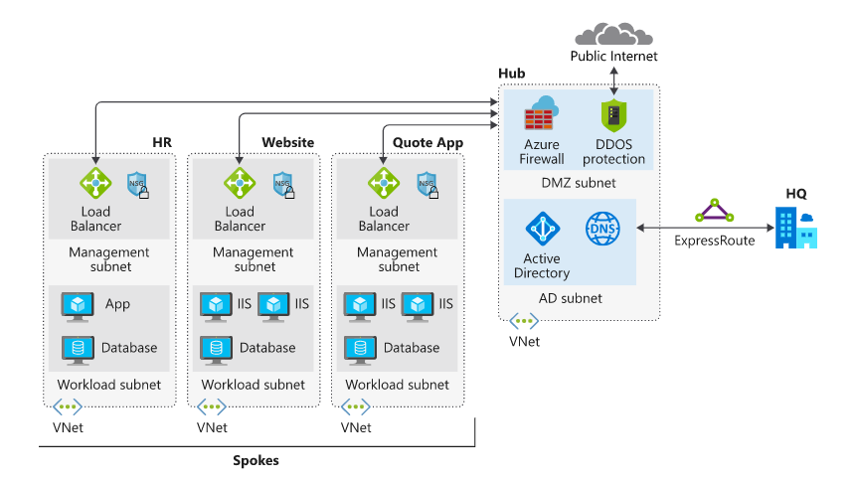

Secure network design on Azure

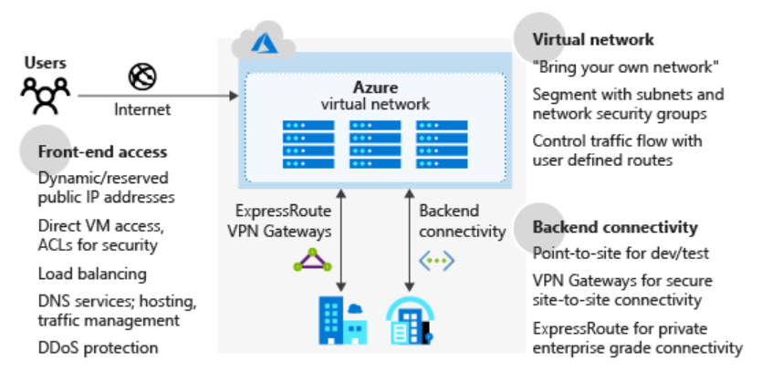

There are several features to consider as part of securing a network design:
- Azure Virtual Network: Provides a base layer of security by logically isolating your environments in Azure, to prevent unauthorized or unwanted access.
- Azure DNS: A hosting service for your domain names. Azure DNS is a secure service that manages and resolves domain names in your virtual network.
- Azure Application Gateway: A dedicated virtual appliance that provides an application delivery controller as a service, including a web application firewall (WAF).
- Azure Traffic Manager: A service to control the distribution of user traffic in Azure.
- Azure Load Balancer: Provides high availability and network performance to your Azure applications.
- Perimeter network: Segments assets between your Azure virtual network and the internet.
Additionally, consider incorporating some of the following into your network architecture to improve network security:
- Network access controls, to make sure that your Azure services are accessible to only the users and devices you want.
- Network security groups as a packet filtering firewall, to control virtual network traffic.
- Route control, and forced tunneling, to define custom routes through your infrastructure, and ensure services can't connect to an internet device.
- Enabling a virtual network security appliance through Azure Marketplace.
- Using Azure ExpressRoute for a dedicated WAN link, to securely extend your on-premises networks to Azure.
- Microsoft Defender for Cloud to prevent, detect, and respond to threats against your Azure services.
- Azure Firewall as a network security service.

Azure Firewall
Microsoft manages this network security service. It protects Azure virtual networks and their resources by letting you manage and enforce connectivity policies centrally. Azure Firewall uses a static, public IP address for virtual network resources, allowing outside firewalls to identify your virtual network traffic.
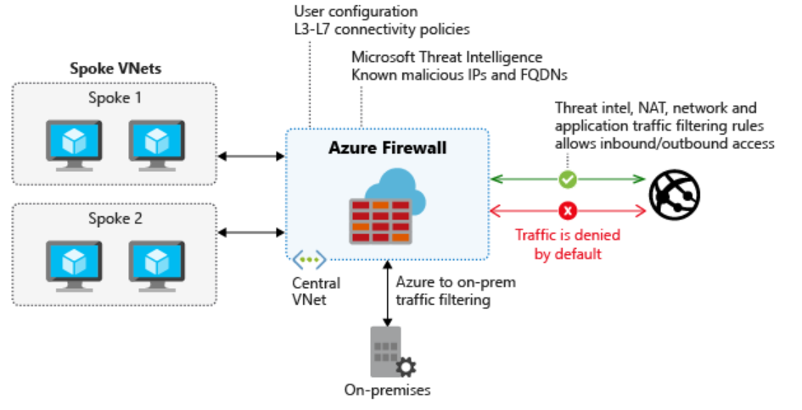

Additional security considerations
The ability to control how traffic is routed through your resources is an important security measure to take. Azure helps you improve the security of your overall infrastructure by offering other services:
- Application security groups: Provides central policy and security management for your applications. Use application security groups to define detailed network security policies by using a moniker. You can then use a zero-trust approach, where only specified flows are permitted.
- Azure Network Watcher: Enables insights into your network logging and diagnostics. Network Watcher allows you to understand the health and performance of your Azure networks.
- Virtual network service endpoints: Extends your virtual network private address space to make it available to Azure services. The endpoints allow you to restrict access to Azure resources.
- Azure DDoS Protection: Allows you to mitigate volumetric, protocol, and resource layer attacks.

Monitor and troubleshoot your end-to-end Azure network infrastructure by using network monitoring tools

When you have to diagnose network problems in Azure, use Azure Network Watcher

In this module, you'll learn about the core Network Watcher features. Engineers use Network Watcher to monitor, diagnose, and gain insight into their network health and performance with metrics. You can break the elements down into four areas: monitoring, network diagnostic tools, metrics, and logs.

Troubleshoot a network by using Network Watcher monitoring and diagnostic tools

What is Network Watcher?
Network Watcher is an Azure service that combines tools in a central place to diagnose the health of Azure networks. The Network Watcher tools are divided into two categories:
- Monitoring tools
- Diagnostic tools
With tools to monitor for and diagnose problems, Network Watcher gives you a centralized hub for identifying network glitches, CPU spikes, connectivity problems, memory leaks, and other issues before they affect your business.
Network Watcher provides three monitoring tools:
- Topology
- Connection Monitor
- Network Performance Monitor

What is the topology tool?
Suppose you have to troubleshoot a virtual network created by your colleagues. Unless you were involved in the network creation process, you might not know about all the aspects of the infrastructure. You can use the topology tool to visualize and understand the infrastructure you're dealing with before you start troubleshooting.

- Sign in to the Azure portal, and then search for and select Network Watcher.
- In the Network Watcher menu, under Monitoring, select Topology.
- Select a subscription, the resource group of a virtual network, and then the virtual network itself.
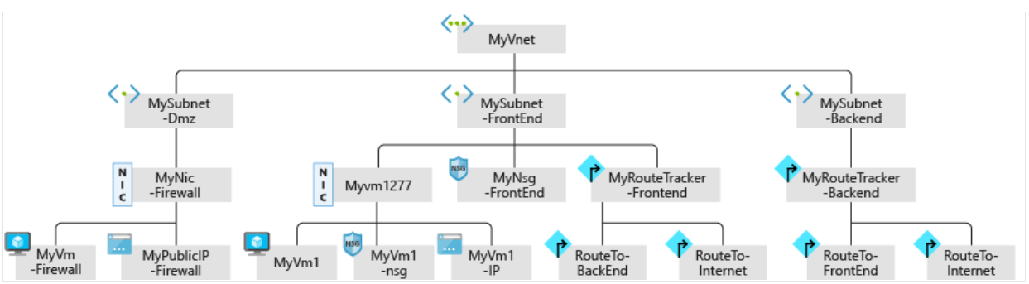

What is the Connection Monitor tool?
The Connection Monitor tool provides a way to check that connections work between Azure resources. Use this tool to verify that two VMs can communicate if you want them to.
This tool also measures the latency between resources. It can catch changes that will affect connectivity, such as changes to the network configuration or changes to network security group (NSG) rules. It can probe VMs at regular intervals to look for failures or changes.
If there's an issue, Connection Monitor tells you why it occurred and how to fix it. Along with monitoring VMs, Connection Monitor can examine an IP address or fully qualified domain name (FQDN).

What is the Network Performance Monitor tool?
The Network Performance Monitor tool lets you track and alert on latency and packet drops over time. It gives you a centralized view of your network.
When you decide to monitor your hybrid connections using Network Performance Monitor, check that the associated workspace is in a supported region.
You can use Network Performance Monitor to monitor endpoint-to-endpoint connectivity:
- Between branches and datacenters
- Between virtual networks
- For your connections between on-premises and the cloud
- For Azure ExpressRoute circuits

Network Watcher diagnostic tools
Network Watcher includes six diagnostic tools:
- IP flow verify
- Next hop
- Effective security rules
- Packet capture
- Connection troubleshoot
- VPN troubleshoot

What is the IP flow verify tool?
The IP flow verify tool tells you whether packets are allowed or denied for a specific virtual machine. If a network security group denies a packet, the tool tells you the name of that group so you can fix the problem.

What is the next hop tool?
When a VM sends a packet to a destination, it might take multiple hops in its journey. For example, if the destination is a VM in a different virtual network, the next hop might be to the virtual network gateway that routes the packet to the destination VM.

What is the effective security rules tool?
The effective security rules tool in Network Watcher displays all the effective NSG rules applied to a network interface.

What is the packet capture tool?
The packet capture tool records all of the packets sent to and from a VM. When enabled, you can review the capture to gather statistics about network traffic or diagnose anomalies, such as unexpected network traffic on a private virtual network.

What is the connection troubleshoot tool?
You use the connection troubleshoot tool to check TCP connectivity between a source and destination VM. You can specify the destination VM by using an FQDN, a URI, or an IP address.

What is the VPN troubleshoot tool?
You can use the VPN troubleshoot tool to diagnose problems with virtual network gateway connections. This tool runs diagnostics on a virtual network gateway connection and returns a health diagnosis.

Azure Network Watcher use case scenarios

There are connectivity issues in a single-VM network

A VPN connection isn't working

No servers are listening on designated destination ports

az network watcher configure \
--enabled true \
--resource-group $RG \
--locations <location>
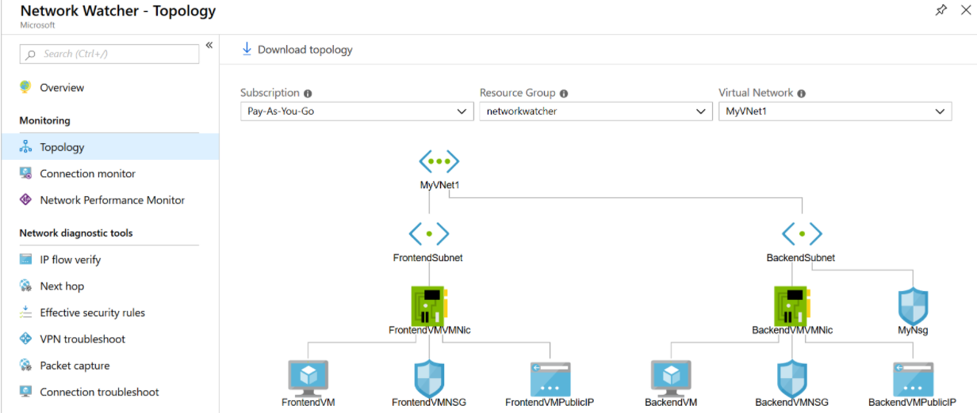

Use Connection Monitor to run tests from the backend to the frontend
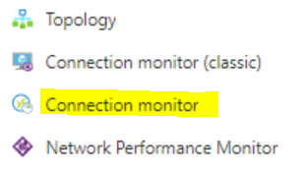
Create
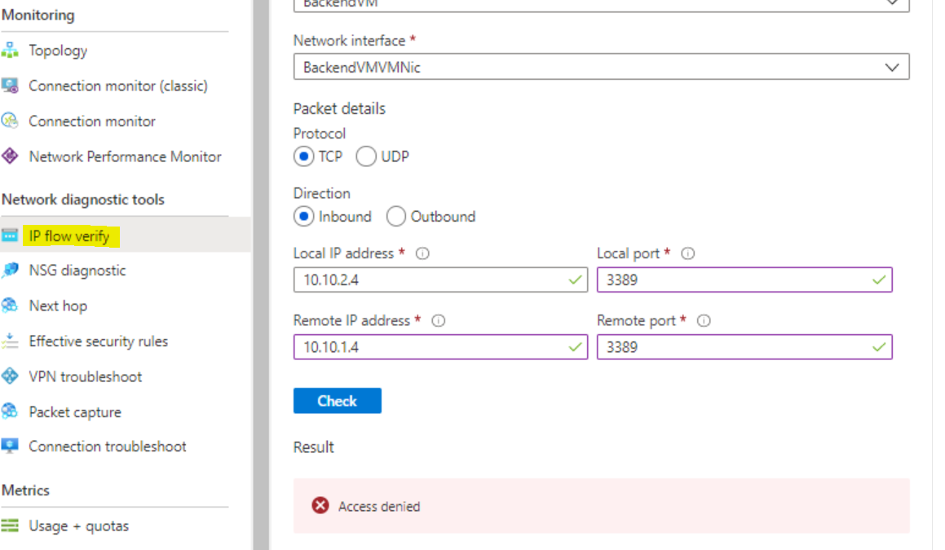

Logs
Network diagnostic logs provide granular data. You'll use this data to understand connectivity and performance issues better. There are three log display tools in Network Watcher:
- Flow logs
- Diagnostic logs
- Traffic analytics

Flow logs
In flow logs, you can view information about ingress and egress IP traffic on network security groups. Flow logs show outbound and inbound flows on a per-rule basis, based on the network adapter the flow applies. NSG flow logs show whether traffic was allowed or denied based on the 5-tuple information captured. This information includes:
- Source IP
- Source port
- Destination IP
- Destination port
- Protocol

Flow logs store data in a JSON file. It can be difficult to gain insights into this data by manually searching the log files, especially if you have a large infrastructure deployment in Azure. To solve this problem, use Power BI.
In Power BI, you can visualize NSG flow logs in many ways. For example:
- Top talkers (IP address)
- Flows by direction (inbound and outbound)
- Flows by decision (allowed and denied)
- Flows by destination port

Diagnostic logs
In Network Watcher, diagnostic logs are a central place to enable and disable logs for Azure network resources. These resources might include NSGs, public IPs, load balancers, and app gateways. After you've enabled the logs that interest you, you can use the tools to query and view log entries.

Traffic analytics
To investigate user and app activity across your cloud networks, use traffic analytics.
The tool gives insights into network activity across subscriptions. You can diagnose security threats such as open ports, VMs communicating with known bad networks, and traffic flow patterns. Traffic analytics analyzes NSG flow logs across Azure regions and subscriptions. You can use the data to optimize network performance.

Use case scenarios
Now, let's look at some use case scenarios where Azure Network Watcher metrics and logs can be helpful.

Customer reports of slow performance

CPU bottlenecks

Memory bottlenecks

Disk bottlenecks

Virtual machine firewall rules that block traffic

Inability of the front end and back end subnets to communicate

